Exp.no:1(a) DDL AND DML COMMANDS
Date:
AIM:
To execute the Data Definition Language (DDL) commands and Data Manipulation Language (DML) Commands.

DATA DEFINITION LANGUAGE
1. Creating a Table:
Create command is used to create a table in the database.
Syntax:
create table tablename (column 1 datatype 1, …., column n datatype n);
2. DESC COMMAND
This command is used to view the structure of the table.
Syntax:
desc tablename; (or)
describe tablename;
3. ALTERING A TABLE
The structure of the table can be changed using this command like add
new column, change the width of a datatype, change the datatype of a column.
- Modify
Syntax:
alter table tablename modify (column datatype, …);
B. Add / Drop
Syntax:
alter table tablename add (column datatype, …);
alter table tablename drop columnname;
4. TRUNCATING A TABLE
This command is used to delete all records stored in a table, but the structure of the table is retained.
Syntax:
truncate table tablename;
5. DROPPING A TABLE
This command is used to remove a table from the database.
Syntax: drop table tablename;

DATA MANIPULATION LANGUAGE
1. INSERT COMMANDS
1. Insert a row with values for columns in a table.
This insert command is used to add rows to a table in the database.
Syntax:
insert into tablename values (value1, value2,……, value n);
insert into tablename(column 1,column 2) values(value 1,value 2);
2. Insert a large number of rows.
This insert command is used to add multiple rows to a table in the
Database in user friendly manner..
Syntax:
insert into tablename values (&column1, &column 2,……, &column n);
2. SELECT COMMANDS
1. Select all rows from a table.
This select command is used to retrieve all the values stored in the table.
Syntax: select * from tablename;
Select column name(s) from tablename;
Select distinct column name from tablename;
2. Select using where command:
This select command is used to retrieve the particular field values, stored in the table, which satisfy a required condition.
Syntax: select column name(s) from tablename where search condition;
select * from tablename where search condition;
3. UPDATE COMMAND
This command is used to update (changing values in) one or two columns
of a row in a table. Specific rows can be updated based on some condition.
Syntax:
update tablename set column1=expression, column 2=expression, ……, column n=expression;
update tablename set column1=expression, column 2=expression, ……, column n=expression where search condition;
4. DELETE COMMAND
A delete query is expressed in much the same way as Query. We can delete whole tuple (rows) we can delete values on only particulars attributes.
1.Deletion of all rows:
Syntax delete from tablename ;

2.Deletion of specified number of rows:
Syntax delete from tablename where search condition ;

RENAME COMMAND

Renaming Table name
Syntax rename oldtablename to newtablename;

Renaming columns used with Expression Lists
Syntax
Select columnname result_columnname, Columnname result_columnname from tablename;

OUTPUT
1. Create EMP table.
SQL>create table emp(empno number(4), ename varchar2(10), job varchar2(9), mgr number(4), hiredate date, sal number(7,2), comm Number(7,2), deptno number(3), age number(3), esal number(10));

2.Get the description EMP table.
Name Null? Type
-------------------------------- ----------------------- -------------------------
EMPNO NUMBER(4)
ENAME VARCHAR2(10)
JOB VARCHAR2(9)
MGR NUMBER(4)
HIREDATE DATE
SAL NUMBER(7,2)
COMM NUMBER(7,2)
DEPTNO NUMBER(3)
AGE NUMBER(3)
ESAL NUMBER(10)

3. Create DEPT table.
SQL>create table dept(deptno number(2) , dname varchar2(14), loc varchar2(13));

4.Get the description DEPT table.
SQL>desc dept;
Name Null? Type
--------------------------------- --------------------- ---------------------------
DEPTNO NUMBER(2)
DNAME VARCHAR2(14)
LOC VARCHAR2(13)

5. Insert records into EMP & DEPT.
SQL> insert into emp values(&empno,’&ename’,’&job’,&mgr,’&date’,&sal,&comm. deptno,&age, &esal);

SQL>insert into dept values(&deptno,’&dname’,’&loc’);

6. List all employee details.
SQL>select * from emp;
EMPNO ENAME JOB MGR HIREDATE SAL COMM DEPTNO AGE ESAL
----------- ---------- ------ -------- ---------------- ------ ---------- ------------- ------ ----
7369 SMITH CLERK 7902 17-DEC-80 800 0 20 25 0
7499 ALLEN SALESMAN 7698 20-FEB-81 1600 300 30 25 0
7521 WARD SALESMAN 7698 22-FEB-81 1250 500 30 25 0
7566 JONES MANAGER 7839 02-APR-81 2975 500 20 25 0
7698 BLAKE MANAGER 7839 01-MAY-81 2850 1400 30 25 0
7. List all dept details
SQL>select * from dept;
DEPTNO DNAME LOC
------------ ------------ --------
10 accounting New york
20 research Dallas
30 Sales Chicago
40 operations Boston

8. List the employees belonging to the department 20.
SQL> select * from emp where deptno=20;
ENAME
SMITH
JONES
9. List the name and salary of the employees whose salary is more than 1000.
SQL >select ename,sal from emp where sal>1000;
ENAME SAL
----------- --------
ALLEN 1600
WARD 1250
JONES 2975
BLAKE 2850

10. List the names of employees who are managers
SQL >select ename from emp where job = ‘MANAGER’
ENAME
---------
JONES
BLAKE

11. List the different jobs available in employee table.
SQL>select distinct job from emp;
JOB
---------
CLERK
MANAGER
SALESMAN
3 rows selected.

12. Alter emp table to add city column which is of string data type.
SQL>Alter table emp add city varchar2(20);
Table altered

13. Alter dept table to change loc column size as 20.
SQL>Alter table dept modify city varchar2(30);
Table altered

14. Update the salary of the employee as 2500 whose job as manager.
SQL>update emp set esal=2500 where job =‘manager’;

15. Delete the employee’s record whose salary is above 2800.
SQL>delete emp where esal>2800;
1 row deleted.

16. Change the name of emp table as EMPLOYEE.
SQL>rename emp to employee;
Table renamed.

17. Delete all records from dept table.
SQL>truncate table dept;
Table truncated.

18. Delete dept table.
SQL>drop table dept;
Table dropped.

CONCLUSION :
Thus the DDL and DML commands are executed successfully.

Ex.No:1(b) DCL & TCL Commands
Date:
AIM:
To study Data Control Language statements and Transactional Control Language statements.

TRANSACTION CONTROL LANGUAGE:
All changes made to the database is defined as a transaction. It is logical unit of work. The transaction can made permanent to a database only they are committed. A transaction begins with an executable SQL statement.
The two transaction control commands are:
- COMMIT
- SAVEPOINT
- ROLLBACK
1. COMMIT:
This command is used to make all transaction changes permanent to the database.
Syntax:
COMMIT ;
2. SAVEPOINT:
It is only a marker. Save point are used to divide a lengthy transaction into smaller ones.
Syntax:
Savepoint id;
3. ROLLBACK:
Rollback commands undo all the changes made in the current transaction.
Syntax:
- Rollback;
- Rollback to Savepoint id1;
The first one will rollback (undo) the entire transaction and the last one will undo all changes made after the creation of the save point id1.
DATA CONTROL LANGUAGE:
Data control language, the previous user with privileges commands the database object (table, view, etc) of a user can’t be accessed by another user without the permission of a user. The owner can allow other user to access his object as per his diversion the permission given by a user to another is called privilege.
The Data Control Commands are:
- GRANT Privilege
- REVOKE Privilege
Types of Privilege:
A permission granted to execute the various data definition command like Create Table, Create Sequence, create session are called System Privilege.
Granting System Privilege:
Grant Command is used to give System Privilege to an oracle user.
Syntax:
GRANT system privilege TO user;
Object Privilege:
An Object Privilege enables a user to execute some commands on the database object like table view sequence etc.
• Object privileges vary from object to object.
• An owner has all the privileges on the object.
• An owner can give specific privileges on that owner’s object.
Some of the object privileges are
- Alter
- Insert
- Update
- Delete
- Select
Syntax:
GRANT object_priv [(columns)]
ON object
TO {user|role|PUBLIC}
[WITH GRANT OPTION];

object_priv -- is an object privilege to be granted
ALL --specifies all object privileges
columns --specifies the column from a table or view on which privileges are granted
ON object -- is the object on which the privileges are granted
TO --identifies to whom the privilege is granted
PUBLIC --grants object privileges to all users
WITH GRANT OPTION --allows the grantee to grant the object privileges to other users and roles.

Example:
• Grant query privileges on the EMPLOYEES table.
GRANT select ON employees TO itc20,itc30;
Grant succeeded.

• Grant privileges to update specific columns to users and roles.
GRANT update (department_name, location_id) ON departments
TO itc43, itc50;
Grant succeeded.

Give a user authority to pass along privileges.
GRANT select, insert ON departments TO itc45 WITH GRANT OPTION;
Grant succeeded.

Revoking the permission:
Permission granted to a user can also be taken back by the granter. This can be done by the REVOKE command.
• Privileges granted to others through the WITH GRANT OPTION clause are also revoked.
Syntax:
REVOKE {privilege [, privilege...]|ALL}
ON object
FROM {user[, user...]|role|PUBLIC}
[CASCADE CONSTRAINTS];

Example:
REVOKE select, insert ON departments FROM itc20;
Revoke succeeded.
OUTPUT :
TCL
SQL> desc stud;
Name Null? Type
----------------------------------------- -------- ----------------------------
SNO NUMBER(3)
SNAME VARCHAR2(10)
BRANCH VARCHAR2(4)

SQL> insert into stud values(01,'Arun','cse');
1 row created.
SQL> insert into stud values(02,'babu','IT');
1 row created.
SQL> commit;
Commit complete.
SQL> select * from stud;
SNO SNAME BRAN
---------- ---------- ----
1 Arun cse
2 babu IT
SQL> insert into stud values(03,'chitra','IT');
1 row created.
SQL> select * from stud;

SNO SNAME BRAN
---------- ---------- ----
1 Arun cse
2 babu IT
3 chitra IT
SQL> rollback;
Rollback complete.

SQL> select * from stud;
SNO SNAME BRAN
---------- ---------- ----
1 Arun cse
2 babu IT
SQL> savepoint s1;
Savepoint created.
SQL> insert into stud values(04,'Devi','CSE');
1 row created.
SQL> select * from stud;
SNO SNAME BRAN
---------- ---------- ----
1 Arun cse
2 babu IT
4 Devi CSE
SQL> rollback to s1;
Rollback complete.
SQL> select * from stud;
SNO SNAME BRAN
---------- ---------- ----
1 Arun cse
2 babu IT
DCL
User it2a40:
SQL> grant all on student to it2a36;
Grant succeeded.
User it2a36:
SQL> select * from it2a40.student;
ROLL_NO NAME DEPT SEM1 SEM2 SEM3
---------- ------------ ---------- ---------- ---------- ----------
1 alex ece 92.3 90.5 89.3
2 bala ece 88.2 85 89.3
3 booba it 91.1 85 93
insert into it2a40.student values(&roll_no,'&name','&dept',&sem2,&sem2,&sem3);
Enter value for roll_no: 4
Enter value for name: chitra
Enter value for dept: it
Enter value for sem2: 88.5
Enter value for sem2: 90
Enter value for sem3: 92
old 1: insert into it2a40.student values(&roll_no,'&name','&dept',&sem2,&sem2,&sem3)
new 1: insert into it2a40.student values(4,'chitra','it',88.5,90,92)
1 row created.
SQL> select * from it2a40.student;
ROLL_NO NAME DEPT SEM1 SEM2 SEM3
---------- --------------- ---------- ---------- ---------- ----------
4 chitra it 88.5 90 92
1 alex ece 92.3 90.5 89.3
2 bala ece 88.2 85 89.3
3 booba it 91.1 85 93
SQL> alter table it2a40.student add(avg number(10,3));
Table altered.
SQL> update it2a40.student set avg=91.2 where roll_no=1;
1 row updated.
SQL> update it2a40.student set avg=88.5 where roll_no=2;
1 row updated.
SQL> update it2a40.student set avg=89.9 where roll_no=3;
1 row updated.
SQL> update it2a40.student set avg=90.2 where roll_no=4;
1 row updated.
SQL> select * from it2a40.student;
ROLL_NO NAME DEPT SEM1 SEM2 SEM3 AVG
---------- --------------- ---------- ---------- ---------- ---------- -------------------------------
4 chitra it 88.5 90 92 90.2

1 alex ece 92. 90. 9 89.3 91.2

2 bala ece 88.2 85 89.3 88.5

3 booba it 91.1 85 93 89.9

SQL> delete from it2a40.student where roll_no=4;
1 row deleted.
SQL> select * from it2a40.student;
ROLL_NO NAME DEPT SEM1 SEM2 SEM3 AVG
---------- --------------- ---------- ---------- ---------- ----------------------------------------
1 alex ece 92.3 90.5 89.3 91.2
2 bala ece 88.2 85 89.3 88.5
3 booba it 91.1 85 93 89.9

User it2a40:
SQL> revoke delete on student from it2a36;
Revoke succeeded.
User it2a36:
SQL> delete from it2a40.student where roll_no=2;
delete from it2a40.student where roll_no=2
*
ERROR at line 1:
ORA-00942: table or view does not exist
User it2a40:
SQL> revoke all on student from it2a36;
Revoke succeeded.
User it2a36:
SQL> select * from it2a40.student;
select * from it2a40.student
ERROR at line 1:
ORA-00942: table or view does not exist
User it2a40:
SQL> grant select on student to it2a36;
Grant succeeded.
User - it2a36:
SQL> select * from it2a40.student;
ROLL_NO NAME DEPT SEM1 SEM2 SEM3 AVG
---------- --------------- ---------- ---------- ---------- ----------------------------------------
1 alex ece 92.3 90.5 89.3 91.2
2 bala ece 88.2 85 89.3 88.5
3 booba it 91.1 85 93 89.9

User it2a40:
SQL> revoke select on student from it2a36;
Revoke succeeded.
User it2a36:
SQL> select * from it2a40.student;
select * from it2a40.student
*
ERROR at line 1:
ORA-00942: table or view does not exist

Conclusion:
Thus the study of DCL commands and TCL commands was performed successfully.

Ex.No:2(a) Operators and aggregate function
Date:

AIM:
To implement operators and aggregate function in sql.

AGGREGATE FUNCTIONS

Unlike single-row functions, group functions operate on sets of rows to give one result per group. These sets may be the whole table or the table split into groups.

Types of Aggregate Functions
• AVG
• COUNT
• MAX
• MIN
• STDDEV
• SUM
• VARIANCE
Function Description
Each of the functions accepts an argument. The following table identifies the options that you can use in the syntax:
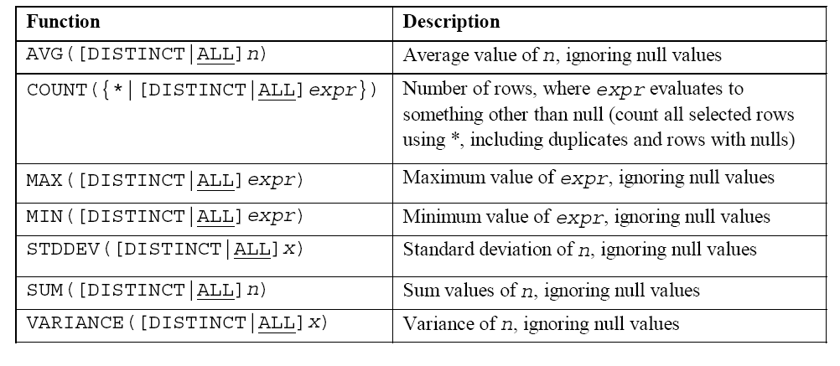
Operators Used in Queries :
Operators | Description
Arithmetic operators
+ | Addition
- | Subtraction
* | multiplication
/ | Division
** | exponentiation
( ) | Enclosed operation
Relational operators
= | Equal to
> | Greater than
< | Less than
>= | Greater than or equal to
<= | Less than or equal to
<>,!=,^= | Not equal to
Logical Operators
AND | all of must be included
OR | any of may be included
NOT | none of could be included
Special Operators
IS NULL | Checking for NULL values
IN | Checking a value in a set
BETWEEN | Checking a value within a range
LIKE | Matching a pattern from a column
Pattern Searching
% | matches multiple characters in string
_ | match with single character

EMP(EMPNO ,ENAME,DESIGNATION,JOBID,HIREDATE, SALARY, COMM, DEPTNO, AGE)

Aggregate Functions Syntax

SELECT [column,] group_function(column), ...
FROM table
[WHERE condition]
[GROUP BY column]
[ORDER BY column];

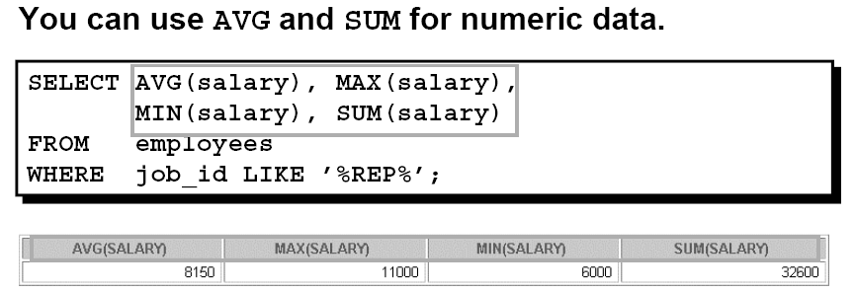

You can use the MAX and MIN functions for any data type.

EXAMPLE
The following example displays the employee last name that is first and the employee last name that is the last in an alphabetized list of all employees.

SELECT MIN(last_name), MAX(last_name)
FROM emp;

Note: AVG, SUM, VARIANCE, and STDDEV functions can be used only with numeric data types.

THE COUNT FUNCTION

The COUNT function has three formats:

- •COUNT(*)
- • COUNT(expr)
- • COUNT(DISTINCT expr)

1. COUNT(*) returns the number of rows in a table that satisfy the criteria of the SELECT statement, including duplicate rows and rows containing null values in any of the columns. If a WHERE clause is included in the SELECT statement, COUNT(*) returns the number of rows that satisfies the condition in the WHERE clause.

→COUNT(*) returns the number of rows in a table.

EXAMPLE
SELECT COUNT(*) FROM emp WHERE deptno= 50;

2. In contrast, COUNT(expr) returns the number of non-null values in the column identified by expr.
EXAMPLE
Display the number of department values in the EMPLOYEES table.

SELECT COUNT(department_id) FROM employees;

3. COUNT(DISTINCT expr) returns the number of unique, non-null values in the column identified by expr.

EXAMPLE
SELECT COUNT(DISTINCT deptno)
FROM emp;

GROUP FUNCTIONS AND NULL VALUES

All group functions ignore null values in the column.
EXAMPLE
SELECT AVG(comm) FROM emp;

Using the NVL Function with Group Functions

The NVL function forces group functions to include null values.

EXAMPLE

SELECT AVG(NVL(comm, 0)) FROM emp;

Writing Queries using GROUP BY, HAVING and ORDER BY clauses:

The GROUP BY Clause
You can use the GROUP BY clause to divide the rows in a table into groups. You can then use the group functions to return summary information for each group.
Order by : The order by clause is used to display the results in sorted order.
In the syntax:
SELECT column, group_function(column)
FROM table
[WHERE condition]
[GROUP BY group_by_expression]
[ORDER BY column];

group_by_expression specifies columns whose values determine the basis for
grouping rows.
EXAMPLE

SELECT deptno, AVG(salary)
FROM emp
GROUP BY deptno;

When using the GROUP BY clause, make sure that all columns in the SELECT list that are not group functions are included in the GROUP BY clause.

USING THE GROUP BY CLAUSE ON MULTIPLE COLUMNS

EXAMPLE
SELECT deptno deptartmentno, job_id, SUM(salary)
FROM emp
GROUP BY deptno, job_id ;

THE HAVING CLAUSE
You use the HAVING clause to specify which groups are to be displayed, and
:SQL applies predicates (conditions) in the having clause after groups have been formed, so aggregate function be used.
Syntax:
SELECT column, group_function
FROM table
[WHERE condition]
[GROUP BY group_by_expression]
[HAVING group_condition]
[ORDER BY column];
EXAMPLE:

SELECT deptno, AVG(salary)
FROM emp
HAVING AVG(salary) > 8000
GROUP BY deptno;

NESTING GROUP FUNCTIONS
Group functions can be nested to a depth of two.
EXAMPLE
Display the maximum average salary.
SELECT MAX(AVG(salary))
FROM emp
GROUP BY deptno;

GROUP FUNCTIONS & OPERATORS

1. List all employee names and their salaries, whose salary lies between
1500/- and 3500/- both inclusive.
SQL>select ename from emp where salary between 1500 and 3500;
2. List all employee names and their manager whose jobid is
7902 or 7566 0r 7789.
SQL>select ename from emp where jobid in(7602,7566,7789);
3. List all employees which starts with either J or T.
SQL>select ename from emp where ename like ‘J%’ or ename like ‘T%’;
4. List all employee names and jobs, whose job title includes M or P.
SQL>select ename, designation from emp where designation like ‘M%’ or job like ‘P%’;
5. List all jobs available in employee table.
SQL>select distinct designation from emp;
6. List all employees who belongs to the department 10 or 20.
SQL>select ename from emp where deptno in (10,20);
7. List all employee names , salary and 15% rise in salary.
SQL>select ename , salary , salary+0.15* salary from emp;
8. List minimum , maximum , average salaries of employee.
SQL>select min(salary),max(salary),avg(salary) from emp;
9. Find how many job titles are available in employee table.
SQL>select count (distinct designation) from emp;
10. What is the difference between maximum and minimum salaries of employees in the organization?
SQL>select max(salary)-min(salary) from emp;
11. Find how much amount the company is spending towards salaries.
SQL>select sum (salary) from emp;
12. Display name of the dept. with deptno 20.
SQL>select ename from emp where deptno = 20;
13. List ename whose commission is NULL.
SQL>select ename from emp where comm is null;
14. Find no.of dept in employee table.
SQL>select count (distinct ename) from emp;
15. List ename whose manager is not NULL.
SQL>select ename from emp where jobid is not null;

16. Display total salary spent for each job category.
SQL>select designation, sum (salary) from emp group by designation;
17. Display number of employees working in each department and their
department name.
SQL> select dname, count (ename) from emp, dept where emp.deptno=dept.deptno
group by dname;
18.List the employee details in ascending order of salary.
SQL> select empno, ename, salary from emp order by sal;
19. List the employee name and hiredate in descending order of hiredate.
SQL> select ename, hiredate as doj from emp order by 2 desc;
20.List the job and salary of employees job wise for department number 30 and display only those rows having salary greater than 1500 .
SQL> select designation, salary from emp where deptno=30 group by designation having salary >1500;

Conclusion:

Thus the implementation of aggregate functions and operators were performed successfully.

Ex.No:3 INTEGRITY CONSTRAINTS

Date:
AIM:
To implement INTEGRITY CONSTRAINTS using SQL.

CONSTRAINTS:
Integrity Constraints ensure that changes made to the database by authorized users do not result in loss of data consistency. Thus, integrity constraints guard against accidental damage to the database.
You can use constraints to do the following:

• Enforce rules on the data in a table whenever a row is inserted, updated, or deleted from that table. The constraint must be satisfied for the operation to succeed.
• Prevent the deletion of a table if there are dependencies from other tables.
• Provide rules for Oracle tools, such as Oracle Developer.
• The following constraint types are valid:
- NOT NULL
- UNIQUE
- PRIMARY KEY
- FOREIGN KEY
- CHECK
- Reference
- Default
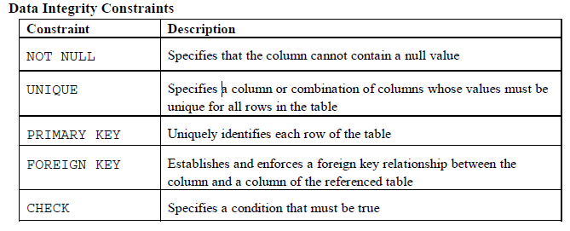
CONSTRAINTS CAN BE CREATED IN THREE WAYS:
1)Column level constraints
2)Table level constraints
3)Using DDL statements-alter table command
OPERATION ON CONSTRAINT:
i)ENABLE
ii)DISABLE
iii)DROP
- DOMAIN INTEGRITY CONSTRAINTS

1. NOT NULL CONSTRAINT

The NOT NULL constraint ensures that the column contains no null values. Columns without the NOT NULL constraint can contain null values by default.

Syntax

create table <table name> (column 1 datatype 1 not null,
……., column n datatype n);

Example

SQL>create table emp7(empno number(4),ename varchar2(20) constraint emp7_ename NOT NULL, design varchar2(20), sal number(3));
Table created.

SQL> desc emp7;
Name Null? Type
----------------------------------------- -------- ----------------------------
EMPNO NUMBER(4)
ENAME NOT NULL VARCHAR2(20)
DESIGN VARCHAR2(20)
SAL NUMBER(3)

To add a NOT NULL constraint, use the ALTER TABLE MODIFY syntax:

ALTER TABLE employees MODIFY (ename constraint emp_ename_nn NOT NULL);

2.CHECK CONSTRAINT
The CHECK constraint defines a condition that each row must satisfy. Check constraints contain an expression the database will evaluate when you modify or insert a row. If the expression evaluates to false, the database will not save the row. Building a check constraint is similar to building a WHERE clause. You can use many of the same operators (>, <, <=, >=, <>, =) in additional to BETWEEN, IN, LIKE, and NULL. You can also build expressions around AND and OR operators.
Syntax for column level constraints using Check:

create table <table name> (column1 datatype, column2 datatype constraint constraintname check(condition),….. column n datatype );

To add a CHECK constraint, use the ALTER TABLE ADD syntax:
alter table <table name> add constraint constraint_name check(condition);

Example:

SQL>create table emp7(empno number(7),ename varchar2(20),sal number(10) constraint emp_sal check(sal>500 and sal<10000));
Table created.

SQL> alter table emp7 add constraint check (sal between 500 and 10000);

- ENTITY INTEGRITY CONSTRAINTS

- UNIQUE CONSTRAINT
Unique key constraint is used to prevent duplication of values within the row of a specified column or a group of table.
Syntax
create table <table name> (column1 datatype, column2 datatype constraint constraintname UNIQUE,….. ,column n datatype );

alter table <table name> add/modify constraint constraint_name unique (column name);

Example:
SQL> create table emp7(empno number(3),ename varchar2(20), desgin varchar2(15)constraint emp_des unique,sal number(5));
Table created.

SQL> alter table emp7 add constraint emp_des unique (desgin);

- PRIMARY KEY CONSTRAINT

A primary key is one or more column in a table which identifies each row in the table uniquely. The constraint does not allow null values and duplicate values in columns. primary key constraint is simply a combination of a unique constraint and a not-null constraint.
Syntax
Column level constraints Using Primary key:
Create table tablename(column1 datatype primary key, column2 datatype,………);

Column level constraints Using Primary key with naming convention:
Create table tablename(column1 datatype constraint constraint name primary key, column2 datatype,………);

Table level constraints Using Primary key:
Create table tablename(column1 datatype, column2 datatype,………, constraint constraint name primary key (COLUMN NAME);

Table level constraint with alter command (primary key):
alter table <table name> add/modify constraint constraint_name
primary key (column name);

Example:
SQL> create table employee(empno number(4) primary key, ename varchar2(10), job varchar2(6), sal number(5), deptno number(7));
Table created.
(or)
SQL> create table employee(empno number(4) constraint emp_empno primary key, ename varchar2(10), job varchar2(6), sal number(5), deptno number(7));
Table created.

SQL> desc employee;
Name Null? Type
----------------------------------------- -------- ----------------------------
EMPNO NOT NULL NUMBER(4)
ENAME VARCHAR2(10)
JOB VARCHAR2(6)
SAL NUMBER(5)
DEPTNO NUMBER(7)

SQL> alter table employee add constraint emp_eno primary key (empno);

- REFERENTIAL INTEGRITY CONSTRAINTS
1. FOREIGN KEY
Reference /foreign key constraint:
A foreign key constraint specifies that the values in a column (or a group of columns) must match the values appearing in some row of another table. We say this maintains the referential integrity between two related tables.
The FOREIGN KEY, or referential integrity constraint, designates a column or combination of columns as a foreign key and establishes a relationship between a primary key or a unique key in the same table or a different table.

FOREIGN KEY constraints can be defined at the column or table constraint level. A composite foreign key must be created by using the table-level definition.
Column level foreign key constraint:
Parent Table:
SQL> create table employee(empno number(40) primary key, ename varchar2(10), job varchar2(6), sal number(5), deptno number(7));
Child Table:
Syntax
Column level foreign key constraint
SQL:> Create table tablename (column1 datatype, column2 datatype FOREIGN KEY references Parenttable name(Columnname> ……………………………);
Column level foreign key constraint with naming conversions:
SQL:> Create table tablename (column1 datatype, column2 datatype Constraint constraintname References Parenttablename(Columnname> ,column3 datatype,……………………………);
Table Level Foreign Key Constraints
SQL:> Create table tablename (column1 datatype, column2 datatype ,column3 datatype, Constraint constraintname FOREIGN KEY(columnname) References Parenttablename(Columnname)……………………………);
Table Level Foreign Key Constraints with Alter command
SQL>Alter table tablename Add Constraint constraintname FOREIGN KEY(columnname) References Parenttablename(Columnname));
Example:
SQL> Create table dept(deptno number(2) primary key, dname varchar2(20), location varchar2(15));
Table created.
SQL> desc dept;
Name Null? Type
----------------------------------------- -------- ----------------------------
DEPTNO NOT NULL NUMBER(2)
DNAME VARCHAR2(20)
LOCATION VARCHAR2(15)

SQL>create table emp4a (empno number(3), deptno number(2) constraint emp4a_deptno_fk references dept(deptno), design varchar2(10));
Table created.
(or)
SQL>create table emp4a (empno number(3), deptno number(2) FOREIGN KEY references dept(deptno), design varchar2(10));
Table created.
SQL> desc emp4a;
Name Null? Type
----------------------------------------- -------- ----------------------------
EMPNO NUMBER(3)
DEPTNO NUMBER(2)
DESIGN VARCHAR2(10)
Default:
The DEFAULT constraint is used to insert a default value into a column.The default value will be added to all new records, if no other value is specified.
Syntax:
SQL:>Create table tablename(column1 datatype, column2 datatype default(value),……... column datatype);

Example:
SQL> create table emp1(sno number(10),sname varchar(10),score number(3) default 80);
Table created.

SQL> insert into emp1(sno,sname) values(10,'john');
1 row created.

SQL> select * from emp1;
SNO SNAME SCORE
---------- ----------
10 john 80
Dropping a Constraint
To drop a constraint, you can identify the constraint name from the USER_CONSTRAINTS and USER_CONS_COLUMNS data dictionary views. Then use the ALTER TABLE statement with the DROP clause. The CASCADE option of the DROP clause causes any dependent constraints also to be dropped.
Syntax:
ALTER TABLE tablname DROP PRIMARY KEY | UNIQUE (column) |CONSTRAINT constraint [CASCADE];
In the syntax:
table is the name of the table
column is the name of the column affected by the constraint
constraint is the name of the constraint
Example :
Alter table employee DROP constraint emp_empno;
Disabling a Constraint
You can disable a constraint without dropping it or re-creating it by using the ALTER TABLE statement with the DISABLE clause.
Syntax :
SQL>ALTER TABLE <TABLE-NAME> DISABLE CONSTRAINT <CONSTRAINT NAME>
Example:
Alter table employee DISABLE constraint emp_empno;

Enabling a Constraint
You can enable a constraint without dropping it or re-creating it by using the ALTER TABLE statement with the ENABLE clause.
Syntax :
SQL>ALTER TABLE <TABLE-NAME> ENABLE CONSTRAINT <CONSTRAINT NAME>
Example:
Alter table employee ENABLE constraint emp_empno;
Conclusion:
Thus the implementation of various constraints was performed successfully.
EX No:4 Set Operations, Joins and Nested Queries
Date:
AIM:
To query multiple tables by using set operators, joins and sub queries.
SET OPERATIONS:
The SET operators combine the results of two or more component queries into one result. Queries containing SET operators are called compound queries. Some of set operators are,
UNION - ows of first query plus rows of second query
UNION ALL - Rows of first query plus rows of second query, including all duplicates
INTERSECT – common rows from all queries
MINUS - All distinct rows that are selected by the first SELECT statement and not selected in the second SELECT statement
Syntax:
select query set operator select query
JOINS:
An SQL join clause combines records from two or more tables in a database. It creates a set that can be saved as a table or used as is. A JOIN is a means for combining fields from two tables by using values common to each. ANSI standard SQL specifies four types of Joins: INNER, OUTER, LEFT, and RIGHT. As a special case, a table (base table, view, or joined table) can JOIN to itself in a self-join.
A programmer writes a JOIN predicate to identify the records for joining. If the evaluated predicate is true, the combined record is then produced in the expected format, a record set or a temporary table.
SQL specifies two different syntactical ways to express joins: "explicit join notation" and "implicit join notation".
The "explicit join notation" uses the JOIN keyword to specify the table to join, and the ON keyword to specify the predicates for the join.
The "implicit join notation" simply lists the tables for joining (in the FROM clause of the SELECT statement), using commas to separate them
Inner Join
Inner join creates a new result table by combining column values of two tables (A and B) based upon the join-predicate. The query compares each row of A with each row of B to find all pairs of rows which satisfy the join-predicate. When the join-predicate is satisfied, column values for each matched pair of rows of A and B are combined into a result row. The result of the join can be defined as the outcome of first taking the Cartesian product (or Cross join) of all records in the tables (combining every record in table A with every record in table B)—then return all records which satisfy the join predicate. Inner join is further classified as equi-joins, as natural joins, or as cross-joins
Syntax:
Explicit Notation:
Select * from table name1 inner join table name2 on table1.fieldname=table2.fieldname;
Select * from table1 inner join table2 using(fieldname);
Implicit Notation
Select * from table1, table2 where table1.fieldname=table2.fieldname;
Equi Join
An equi-join is a specific type of comparator-based join, or theta join that uses only equality comparisons in the join-predicate. Using other comparison operators (such as <) disqualifies a join as an equi-join. The query shown above has already provided an example of an equi-join:
Syntax:
Explicit Notation:
Select * from table1 join table2 on table1.fieldname=table2.fieldname;
Natural join
A natural join offers a further specialization of equi-joins. The join predicate arises implicitly by comparing all columns in both tables that have the same column-names in the joined tables. The resulting joined table contains only one column for each pair of equally-named columns
Explicit Notation:
Select * from table1 natural join table2 on table1.fieldname=table2.fieldname;

Cross join
Cross Join returns the Cartesian product of rows from tables in the join. In other words, it will produce rows which combine each row from the first table with each row from the second table.
Explicit Notation:
Select * from table1 cross join table2 ;
Implicit Notation
Select * from table1,table2;

Outer join
An outer join does not require each record in the two joined tables to have a matching record. The joined table retains each record—even if no other matching record exists. Outer joins subdivide further into left outer joins, right outer joins, and full outer joins, depending on which table(s) one retains the rows from (left, right, or both).

Left outer join
The result of a left outer join (or simply left join) for table A and B always contains all records of the "left" table (A), even if the join-condition does not find any matching record in the "right" table (B). This means that a left outer join returns all the values from the left table, plus matched values from the right table (or NULL in case of no matching join predicate).
Explicit Notation:
Select * from table1 left outer join table2 on table1.fieldname=table2.fieldname
Implicit Notation
SELECT table1.column, table2.column FROM table1, table2 WHERE table1.column = table2.column (+);

Right outer join
A right outer join (or right join) closely resembles a left outer join, except with the treatment of the tables reversed. Every row from the "right" table (B) will appear in the joined table at least once. If no matching row from the "left" table (A) exists, NULL will appear in columns from A for those records that have no match in B.
Explicit Notation:
Select * from table1 right outer join table2 on table1.fieldname=table2.fieldname
Implicit Notation
SELECT table1.column, table2.column FROM table1, table2 WHERE table1.column(+) = table2.column;

Full outer join
Conceptually, a full outer join combines the effect of applying both left and right outer joins. Where records in the FULL OUTER JOINed tables do not match, the result set will have NULL values for every column of the table that lacks a matching row.
Explicit Notation:
Select * from table1 full outer join table2 on table1.fieldname=table2.fieldname

Self-join
A self-join is joining a table to itself means each row of the table is combined with itself and with every other row of the table. The self join is viewed as join of two copies of the same table.
SET OPERATIONS
1. Display the different designation in department 20 and 30.
SQL> select designation from emp where deptno=20
union
select designation from emp where deptno=30;

SQL> select designation from emp where deptno=20 union all select designation from emp where deptno=30;

2. List the jobs common to department 20 and 30.
SQL> select designation from emp where deptno=20 intersect select designation from emp where deptno=30;

3. List the jobs unique to department 20.
SQL> select designation from emp where deptno=20 minus select designation from emp where deptno=10 minus select designation from emp where deptno=30;

(Or)
SQL> select designation from emp where deptno=20 minus select designation from emp where deptno in (10,30);

JOINS:
Tables:
SQL> create table two(deptno number(4) primary key,deptname varchar(10));
Table created.

SQL> create table one(name varchar(10),deptno references two(deptno));
Table created.
Insert these values into table one and table two

SQL> select * from one;
NAME DEPTNO
---------- ----------
anand 31
babu 32
chitra 32

3 rows selected.

SQL> select * from two;

DEPTNO DEPTNAME
---------- ----------
31 sales
32 enggg

Inner join
i.SQL> select * from one, two where one.deptno=two.deptno;

ii.SQL> select * from one inner join two on one.deptno=two.deptno

Equi join
i.SQL> select * from one join two on one.deptno=two.deptno;

ii.SQL> select * from one inner join two using(deptno);

Natural join
i.SQL> select * from one natural join two;

Cross Join
i.SQL> select * from one cross join two;

ii.SQL> select * from one,two;

Left outer join
i.SQL> select * from one left outer join two on one.deptno=two.deptno;

ii. SQL> select * from one,two where one.deptno=two.deptno(+);

Right outer join
i. SQL> select * from one right outer join two on one.deptno=two.deptno;

ii. SQL> select * from one,two where one.deptno(+)=two.deptno;

Full outer join
i.SQL> select * from one full outer join two on one.deptno=two.deptno;

Self join
SQL> create table selfj(empno number(5),ename varchar(7),mgr number(5));
Table created.

Insert values for table selfj

SQL> select * from selfj;
EMPNO ENAME MGR
---------- ------- ----------
7839 kalyan
7566 jones 7839
7876 anand 7788
7934 babu 7782
7777 raja 7934

List out the names of manager with the employee record.
SQL> select worker.ename,manager.ename from selfj worker,selfj manager where worker.mgr=manager.empno;

SUBQUERIES
A subquery is a SELECT statement that is embedded in a clause of another SELECT statement. You can build powerful statements out of simple ones by using subqueries. A Common use of subquery is to perform tests for
1.set memberships,
2.setcomparisons
3.set cardinality.

- The subquery (inner query) executes once before the main query.
- The result of the subquery is used by the main query (outer query).
- A subquery must be enclosed in parentheses.
- Place the subquery on the right side of the comparison condition for readability.

Note: Comparison conditions fall into two classes:
1. single-row operators (>, =, >=, <, <>, <=) and
2. multiple-row operators (IN, ANY, ALL).
The subquery is often referred to as a nested SELECT, sub-SELECT, or inner SELECT statement. The subquery generally executes first, and its output is used to complete the query condition for the main or outer query.

Subquery Syntax

SELECT select_list FROM table WHERE expr operator (SELECT select_list FROM table);

Types of Subqueries

• Single-row subqueries: Queries that return only one row from the inner SELECT statement
• Multiple-row subqueries: Queries that return more than one row from the inner SELECT Statement.
A single-row subquery
Subqueries that returns one row from the inner SELECT statement. This type of subquery uses a single-row operator.

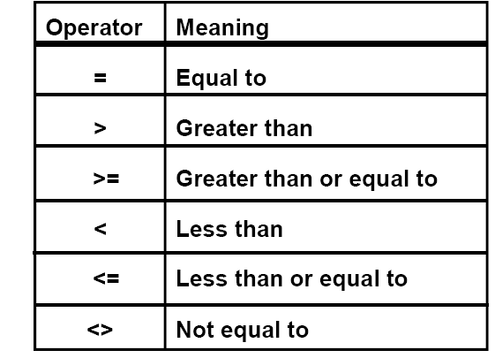

Multiple-Row Subqueries
Subqueries that return more than one row are called multiple-row subqueries. You use a multiple-row operator, instead of a single-row operator, with a multiple-row subquery. The multiple-row operator expects one or more values.
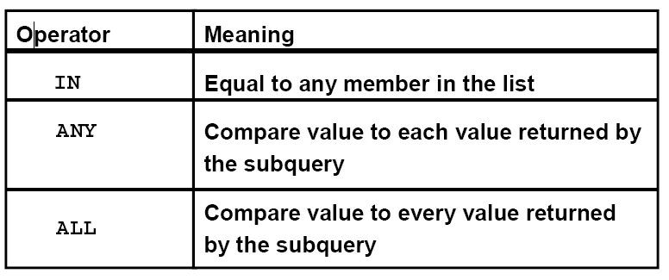

LOAN (Loanno branchname amount)

BORROWER (Loanno cusname)

STUDENT (Sname rollno dept marks)

DEPOSITOR (Cusname Accno)

1.Select loanno, branchname, amount from loan where amount=(select min(amount) from loan)

2. Select sname, rollno, dept, marks from student where marks=(select min(marks) from student group by dept;

3. Select sname, rollno, dept, marks from student where marks IN (select min(marks) from student group by dept)
4. Select sname, rollno, dept, marks from student where marks NOT IN (select min(marks) from student)
5. select * from loan where amount > ANY (select amount from loan where branchname=’chennai’)

6. select * from loan where amount > ALL (select amount from loan where branchname=’chennai’)

7. select * from loan where EXISTS (select * from borrower where loan.loanno=borrower.loanno)

8. select * from loan where NOT EXISTS (select * from borrower where loan.loanno=borrower.loanno)

9. select * from loan where EXCEPT (select * from borrower where loan.loanno=borrower.loanno)

10. Find all customers who have both an account and a loan at the bank.
Select distinct cusname from customer where cusname IN (select cusname from depositor)

11. Find all customers who have a loan at the bank but do not have an account at the bank.
Select distinct cusname from customer where cusname NOT IN (select cusname from depositor)

12. Find the loanno,amount,branchname who have get second maximum loan amount at the bank.
Select loanno, branchname, max(amount) from loan where amount<=(select max(amount) from loan )

13. Write a query that displays the roll numbers and student names of all student who studied in a department with any student whose name contains a S.
SELECT rollno, sname FROM student WHERE dept IN (SELECT dept FROM student WHERE sname like ’%s%’);

14. List the employee names whose salary is greater than the lowest salary of an employee belonging to department number 30.
SQL> select ename from emp
where sal>any
(select sal from emp where deptno=30);

15. List the employee details of those employees whose salary is greater than any of the salesman.
SQL> select empno, ename, sal from emp where sal>any(
select sal from emp where job='asstprof');

16. List the employee names whose salary is greater than the highest salary of an employee belonging to department number 20.
SQL> select ename from emp
where sal>all(select sal from emp where deptno=20);

CONCLUSION :
Thus the implementation of Set Operations, Joins and Nested Queries command are executed successfully.

EX No:5 Creation of Views, Synonyms, Sequence, Indexes, Save point.
AIM:
To create views, synonyms, sequences and indexes using DDL, DML and DCL statements

DESCRIPTION:
Views
- A database view is a logical or virtual table based on a query. It is useful to think of a view as a stored query. Views are queried just like tables.
- A DBA or view owner can drop a view with the DROP VIEW command.
TYPES OF VIEWS
• Updatable views – Allow data manipulation
• Read only views – Do not allow data manipulation
TO CREATE THE TABLE ‘FVIEWS’
SQL> create table fviews( name varchar2(20),no number(5), sal number(5), dno number(5));
Table created.
SQL> insert into fviews values('xxx',1,19000,11);
1 row created.
SQL> insert into fviews values('aaa',2,19000,12);
1 row created.
SQL> insert into fviews values('yyy',3,40000,13);
1 row created.
SQL> select * from fviews;
NAME NO SAL DNO
-------------------- --------- --------- ---------
xxx 1 19000 11
aaa 2 19000 12
yyy 3 40000 13
TO CREATE THE TABLE ‘DVIEWS’
SQL> create table dviews( dno number(5), dname varchar2(20));
Table created.
SQL> insert into dviews values(11,'x');
1 row created.
SQL> insert into dviews values(12,'y');
1 row created.
SQL> select * from dviews;
DNO DNAME
--------- --------------------
11 x
12 y
CREATING THE VIEW ‘SVIEW’ ON ‘FVIEWS’ TABLE
SQL> create view sview as select name,no,sal,dno from fviews where dno=11;
View created.
SQL> select * from sview;
NAME NO SAL DNO
-------------------- --------- --------- ---------
xxx 1 19000 11
Updates made on the view are reflected only on the table when the structure of the table and the view are not similar -- proof
SQL> insert into sview values ('zzz',4,20000,14);
1 row created.
SQL> select * from sview;
NAME NO SAL DNO
-------------------- --------- --------- ---------
xxx 1 19000 11
SQL> select * from fviews;
NAME NO SAL DNO
-------------------- --------- --------- ---------
xxx 1 19000 11
aaa 2 19000 12
yyy 3 40000 13
zzz 4 20000 14
Updates made on the view are reflected on both the view and the table when the structure of the table and the view are similar – proof
CREATING A VIEW ‘IVIEW’ FOR THE TABLE ‘FVIEWS’
SQL> create view iview as select * from fviews;
View created.
SQL> select * from iview;
NAME NO SAL DNO
-------------------- --------- --------- ---------
xxx 1 19000 11
aaa 2 19000 12
yyy 3 40000 13
zzz 4 20000 14
PERFORMING UPDATE OPERATION
SQL> insert into iview values ('bbb',5,30000,15);
1 row created.
SQL> select * from iview;
NAME NO SAL DNO
-------------------- --------- --------- ---------
xxx 1 19000 11
bbb 5 30000 15
SQL> select * from fviews;
NAME NO SAL DNO
-------------------- --------- --------- ---------
xxx 1 19000 11
aaa 2 19000 12
yyy 3 40000 13
zzz 4 20000 14
bbb 5 30000 15
CREATE A NEW VIEW ‘SSVIEW’ AND DROP THE VIEW
SQL> create view ssview( cusname,id) as select name, no from fviews where dno=12;
View created.
SQL> select * from ssview;
CUSNAME ID
-------------------- ---------
aaa 2
SQL> drop view ssview;
View dropped.
TO CREATE A VIEW ‘COMBO’ USING BOTH THE TABLES ‘FVIEWS’ AND ‘DVIEWS’
SQL> create view combo as select name,no,sal,dviews.dno,dname from fviews,dviews where fviews.dno=dviews.dno;
View created.
SQL> select * from combo;
NAME NO SAL DNO DNAME
-------------------- --------- --------- --------- --------------------
xxx 1 19000 11 x
aaa 2 19000 12 y
TO PERFORM MANIPULATIONS ON THIS VIEW
SQL> insert into combo values('ccc',12,1000,13,'x');
insert into combo values('ccc',12,1000,13,'x')
*
ERROR at line 1:
ORA-01779: cannot modify a column which maps to a non key-preserved table
This shows that when a view is created from two different tables no manipulations can be performed using that view and the above error is displayed.
Synonyms
- A synonym is an alias, that is, a form of shorthand used to simplify the task of referencing a database object.
- There are two categories of synonyms, public and private.
- A public synonym can be accessed by any system user.
- The individual creating a public synonym does not own the synonym – rather, it will belong to the PUBLIC user group that exists within Oracle.
- Private synonyms, on the other hand, belong to the system user that creates them and reside in that user's schema.
- A system user can grant the privilege to use private synonyms that they own to other system users.
- In order to create synonyms, we will need to have the CREATE SYNONYM privilege.
- This privilege will be granted to us by the DBA.
- We must have the CREATE PUBLIC SYNONYM privilege in order to create public synonyms.
- If we own a synonym, we have the right to drop (delete) the synonym. The DROP SYNONYM command is quite simple.
- DROP SYNONYM synonym_name;
- In order to drop a public synonym we must include the PUBLIC keyword in the DROP SYNONYM command.
- In order to drop a public synonym, we must have the DROP PUBLIC SYNONYM privilege.
- DROP PUBLIC SYNONYM synonym_name;

Examples:
SQL> select * from class;

NAME ID
---------- ----------
anu 1
brindha 2
chinthiya 3
divya 4
ezhil 5
fairoz 7
hema 9

7 rows selected.

Create synonym:
SQL> create synonym c1 for class;
Synonym created.
SQL> insert into c1 values('kalai',20);
1 row created.
SQL> select * from class;
NAME ID
---------- ----------
anu 1
brindha 2
chinthiya 3
divya 4
ezhil 5
fairoz 7
hema 9
kalai 20
8 rows selected.
SQL> select * from c1;

NAME ID
---------- ----------
anu 1
brindha 2
chinthiya 3
divya 4
ezhil 5
fairoz 7
hema 9
kalai 20
8 rows selected.
SQL> insert into class values('Manu',21);
1 row created.
SQL> select * from c1;
NAME ID
---------- ----------
anu 1
brindha 2
chinthiya 3
divya 4
ezhil 5
fairoz 7
hema 9
kalai 20
Manu 21
9 rows selected.
Drop Synonym:
SQL> drop synonym c1;
Synonym dropped.

SQL> select * from c1;
select * from c1
*
ERROR at line 1:
ORA-00942: table or view does not exist
Sequences
- Oracle provides the capability to generate sequences of unique numbers, and they are called sequences.
- Just like tables, views, indexes, and synonyms, a sequence is a type of database object.
- Sequences are used to generate unique, sequential integer values that are used as primary key values in database tables.
- The sequence of numbers can be generated in either ascending or descending order.
Creation of table:
SQL> create table class(name varchar(10),id number(10));
Table created.
Insert values into table:
SQL> insert into class values('&name',&id);
Enter value for name: anu
Enter value for id: 1
old 1: insert into class values('&name',&id)
new 1: insert into class values('anu',1)
1 row created.
SQL> /
Enter value for name: brindha
Enter value for id: 02
old 1: insert into class values('&name',&id)
new 1: insert into class values('brindha',02)
1 row created.
SQL> /
Enter value for name: chinthiya
Enter value for id: 03
old 1: insert into class values('&name',&id)
new 1: insert into class values('chinthiya',03)
1 row created.

SQL> select * from class;
NAME ID
---------- ----------
anu1
brindha 2
chinthiya3

Create Sequence:
SQL> create sequence s_1
2 start with 4
3 increment by 1
4 maxvalue 100
5 cycle;
Sequence created.
SQL> insert into class values('divya',s_1.nextval);
1 row created.
SQL> select * from class;
NAME ID
---------- ----------
anu 1
brindha 2
chinthiya 3
divya 4
Alter Sequence:
SQL> alter sequence s_1
2 increment by 2;
Sequence altered.
SQL> insert into class values('fairoz',s_1.nextval);
1 row created.
SQL> select * from class;
NAME ID
---------- ----------
anu 1
brindha 2
chinthiya 3
divya 4
ezhil 5
fairoz 7
Drop Sequence:
SQL> drop sequence s_1;
Sequence dropped.
Indexes
- An index can be created in a table to find data more quickly and efficiently.
- The users cannot see the indexes; they are just used to speed up searches/queries.
- Updating a table with indexes takes more time than updating a table without; because the indexes also need an update. So we should only create indexes on columns (and tables) that will be frequently searched against.
Syntax:
Create Index:
CREATE INDEX index_name ON table_name (column_name)

SQL> create table splr(sname varchar(10),sid number(10),scity varchar(10));
Table created.

SQL> insert into splr values('hcl',01,'chennai');
1 row created.

SQL> insert into splr values('dell',04,'madurai');
1 row created.

SQL> insert into splr values('HP',02,'kovai');
1 row created.

SQL> insert into splr values('Lenovo',03,'trichy');
1 row created.

SQL> select * from splr;

SNAME SID SCITY
---------- ---------- ----------
hcl 1 chennai
dell 4 madurai
HP 2 kovai
Lenovo 3 trichy

SQL> create index sp1 on splr(sid);
Index created.

SQL> create index sp2 on splr(sid,scity);
Index created.
Drop Index:
SQL> drop index sp1;
Index dropped.

SQL> drop index sp2;
Index dropped.

CONCULSION:

Thus views, synonyms, sequences and indexes using DDL, DML and DCL statements was executedd successfully.

Ex.No:6(a) Implementation of PL/SQL
Date:

Aim:
To Implement the basics of PL/SQL.

Theory & Concepts:

PL/SQL is the procedural extension to SQL with design features of programming languages. Data manipulation and query statements of SQL are included within procedural units of code.
Benefits of PL/SQL:

PL/SQL can improve the performance of an application. The benefits differ depending on the execution environment:
- PL/SQL can be used to group SQL statements together within a single block and to send the entire block to the server in a single call thereby reducing networking traffic. Without PL/SQL, the SQL statements are sent to the Oracle server one at a time. Each SQL statement results in another call to the Oracle server and higher performance overhead. In a network environment, the overhead can become significant.
- PL/SQL can also operate with Oracle server application development tools such as Oracle forms and Oracle reports.
PL/SQL Block Structure:

Every unit of PL/SQL comprises one or more blocks. These blocks can be entirely separate or nested one within another. The basic units (procedures, functions, and anonymous blocks) that make up a PL/SQL program are logical blocks which can contain any number of nested sub-blocks. Therefore one block can represent a small part of another block, which in turn can be part of the whole unit of code.
Identifiers/Variables:

In PL/SQL, you can use identifiers to do the following:
- Declare variables, cursors, constants and exceptions and then use them in SQL and procedural statements.
- Declare variables belonging to scalar, reference, composite and large object (LOB) data types.
- Declare variables dynamically based on the data structure of tables and columns in the database.

PL/SQL Block Syntax:

DECLARE [Optional]
Variables, cursors, user defined exceptions
BEGIN [Mandatory]
- SQL Statements –
- PL/SQL Statements –
Exception [Optional]
-- Actions to be performed when errors occur ----
END [Mandatory];

Anonymous, procedure and function blocks:

Anonymous:
- No name.
- Starts with DECLARE statement.

Procedure:
- No return.
- PROCEDURE name IS

Function:
- Returns a value
- FUNCTION name RETURN data-type IS

Programming Constructs:

Declaring Variables:

Identifier [CONSTANT] data-type [NOT NULL] [:= | DEFAULT expr];

Assignment:
Identifier := expr;

IF Statement:

IF condition THEN
Statements;
[ELSE IF condition THEN
Statements;]
[ELSE
Statements;]
END IF;

CASE Statement:

CASE selector
WHEN expression1 THEN result1
WHEN expression2 THEN result2
. . . .
. . . .
WHEN expression THEN resultn
[ELSE resultn1;]
END;
BASIC Loops:

LOOP
Statement 1;
. . . .
. . . .
EXIT [WHEN condition];
END LOOP;
WHILE Statement:

WHILE condition LOOP
Statement1;
. . . .
. . . .
END LOOP;
FOR Statement:

FOR counter IN [REVERSE]
Lower_bound..upper_bound LOOP
Statement1;
. . . .
. . . .
END LOOP;
i.)Write a program in PL/SQL for addition of two numbers.
SQL>declare
no1 number:=&a;
no2 number:=&b;
begin
dbms_output.put_line('Sum:'||(no1+no2));
end;
/
Enter value for a: 10
old 2: no1 number:=&a;
new 2: no1 number:=10;
Enter value for b: 2
old 3: no2 number:=&b;
new 3: no2 number:=2;
Sum:12

PL/SQL procedure successfully completed.
ii.)Write a program in PL/SQL for addition of 1 to 100 numbers.
Declare
a number;
s1 number default 0;
Begin
a:=1;
loop
s1:=s1+a;
exit when (a=100);
a:=a+1;
end loop;
dbms_output.put_line('Sum between 1 to 100 is '||s1);
End;
/
Sum between 1 to 100 is 5050

PL/SQL procedure successfully completed.

iii.)Write a program in PL/SQL to inverse a number, eg. Number 5639 when inverted must be display output 9365.
Declare
given_number varchar(5) := '5639';
str_length number(2);
inverted_number varchar(5);
Begin
str_length := length(given_number);
For cntr in reverse 1..str_length
loop
inverted_number := inverted_number || substr(given_number, cntr, 1);
end loop;
dbms_output.put_line('The Given no is ' || given_number);
dbms_output.put_line('The inverted number is ' || inverted_number);
end;
/
The Given no is 5639
The inverted number is 9365

PL/SQL procedure successfully completed.

CONCLUSION:
Thus the PL/SQL programs were written and executed to accept the input from the users.

Ex.No:6(b) IMPLEMENTATION OF CURSORS
CURSOR PROGRAM FOR ELECTRICITY BILL CALCULATION:
SQL> create table bill(name varchar2(10), address varchar2(20), city varchar2(20), unit
number(10));
Table created.
SQL> insert into bill values('&name','&addess','&city','&unit');
Enter value for name: yuva
Enter value for addess: srivi
Enter value for city: srivilliputur
Enter value for unit: 100
old 1: insert into bill values('&name','&addess','&city','&unit')
new 1: insert into bill values('yuva','srivi','srivilliputur','100')
1 row created.
SQL> /
Enter value for name: nithya
Enter value for addess: Lakshmi nagar
Enter value for city: sivakasi
Enter value for unit: 200
old 1: insert into bill values('&name','&addess','&city','&unit')
new 1: insert into bill values('nithya','Lakshmi nagar','sivakasi','200')
1 row created.
SQL> /
Enter value for name: maya
Enter value for addess: housing board
Enter value for city: sivakasi
Enter value for unit: 300
old 1: insert into bill values('&name','&addess','&city','&unit')
new 1: insert into bill values('maya','housing board','sivakasi','300')
1 row created.
SQL> /
Enter value for name: jeeva
Enter value for addess: RRR nagar
Enter value for city: sivaganagai
Enter value for unit: 400
old 1: insert into bill values('&name','&addess','&city','&unit')
new 1: insert into bill values('jeeva','RRR nagar','sivaganagai','400')
1 row created.
SQL> select * from bill;
NAME ADDRESS CITY UNIT
---------- -------------------- -------------------- ---------
yuva srivi srivilliputur 100
nithya Lakshmi nagar sivakasi 200
maya housing board sivakasi 300
jeeva RRR nagar sivaganagai 400
SQL> declare
2 cursor c is select * from bill;
3 b bill %ROWTYPE;
4 begin
5 open c;
6 dbms_output.put_line('Name Address city Unit Amount');
7 loop
8 fetch c into b;
9 if(c % notfound) then
10 exit;
11 else
12 if(b.unit<=100) then
13 dbms_output.put_line(b.name||' '||b.address||' '||b.city||' '||b.unit||' '||b.uni
t*1);
14 elsif(b.unit>100 and b.unit<=200) then
15 dbms_output.put_line(b.name||' '||b.address||' '||b.city||' '||b.unit||' '||b.
unit*2);
16 elsif(b.unit>200 and b.unit<=300) then
17 dbms_output.put_line(b.name||' '||b.address||' '||b.city||' '||b.unit||' '||b.
unit*3);
18 elsif(b.unit>300 and b.unit<=400) then
19 dbms_output.put_line(b.name||' '||b.address||' '||b.city||' '||b.unit||' '||b.unit*
4);
20 else
21 dbms_output.put_line(b.name||' '||b.address||' '||b.city||' '||b.unit||' '||b.unit*
5);
22 end if;
23 end if;
24 end loop;
25 close c;
26 end;
27 /
Name Address city Unit Amount
yuva srivi srivilliputur 100 100
nithya Lakshmi nagar sivakasi 200 400
maya housing board sivakasi 300 900
jeeva RRR nagar sivaganagai 400 1600
PL/SQL procedure successfully completed.
PROGRAM FOR STUDENT GRADE CALCULATION
SQL> create table std(name varchar(10), rollno number(3),mark1 number(3), mark2
number(3), mark3 nu
mber(3));
Table created.
SQL> insert into std values('&name','&rollno','&mark1','&mark2','&mark3');
Enter value for name: gowri
Enter value for rollno: 101
Enter value for mark1: 78
Enter value for mark2: 89
Enter value for mark3: 99
old 1: insert into std values('&name','&rollno','&mark1','&mark2','&mark3')
new 1: insert into std values('gowri','101','78','89','99')
1 row created.
SQL> /
Enter value for name: prem
Enter value for rollno: 102
Enter value for mark1: 88
Enter value for mark2: 99
Enter value for mark3: 90
old 1: insert into std values('&name','&rollno','&mark1','&mark2','&mark3')
new 1: insert into std values('prem','102','88','99','90')
1 row created.
SQL> /
Enter value for name: ravathi
Enter value for rollno: 103
Enter value for mark1: 67
Enter value for mark2: 89
Enter value for mark3: 99
old 1: insert into std values('&name','&rollno','&mark1','&mark2','&mark3')
new 1: insert into std values('ravathi','103','67','89','99')
1 row created.
SQL> /
Enter value for name: arun
Enter value for rollno: 104
Enter value for mark1: 56
Enter value for mark2: 66
Enter value for mark3: 77
old 1: insert into std values('&name','&rollno','&mark1','&mark2','&mark3')
new 1: insert into std values('arun','104','56','66','77')
1 row created.
SQL> set serveroutput on;
SQL> declare
2 tot number;
3 average number;
4 cursor c is select * from std;
5 s std %ROWTYPE;
6 begin
7 open c;
8 dbms_output.put_line('Name Rollno Mark1 Mark2 Mark3 Total Average
Grade');
9 loop
10 fetch c into s;
11 tot:=s.mark1+s.mark2+s.mark3;
12 average:=floor(tot/3);
13 if(c % notfound)then
14 exit;
15 else
16 if(s.mark1<50 or s.mark2<50 or s.mark3<50)then
17 dbms_output.put_line(s.name||' '||s.rollno||' '||s.mark1||' '||s.mark2||' '||s.mark3||
' '||tot||' '||average||' '||'F');
18 elsif(average>=90 and average<=100)then
19 dbms_output.put_line(s.name||' '||s.rollno||' '||s.mark1||' '||s.mark2||' '||s.mark3||
' '||tot||' '||average||' '||'S');
20 elsif(average>=80 and average<90)then
21 dbms_output.put_line(s.name||' '||s.rollno||' '||s.mark1||' '||s.mark2||' '||s.mark3||
' '||tot||' '||average||' '||'A+');
22 elsif(average>=70 and average<80)then
23 dbms_output.put_line(s.name||' '||s.rollno||' '||s.mark1||' '||s.mark2||' '||s.mark3||
' '||tot||' '||average||' '||'B');
24 elsif(average>=60 and average<70)then
25 dbms_output.put_line(s.name||' '||s.rollno||' '||s.mark1||' '||s.mark2||' '||s.mark3||
' '||tot||' '||average||' '||'C');
26 else
27 dbms_output.put_line(s.name||' '||s.rollno||' '||s.mark1||' '||s.mark2||' '||s.mark3||
' '||tot||' '||average||' '||'D');
28 end if;
29 end if;
30 end loop;
31 close c;
32 end;
33 /
Name Rollno Mark1 Mark2 Mark3 Total Average Grade
gowri 101 78 89 99 266 88 A+
prem 102 88 99 90 277 92 S
ravathi 103 67 89 99 255 85 A+
arun 104 56 66 77 199 66 C
PL/SQL procedure successfully completed.

CONCLUSION:
Thus the program to implement cursors was executed and output was verified successfully

Ex. No: 7(a) Creation of Procedures
Date:

Aim:
To create and implement the PL/SQL procedures.

QUERIES:

i.)Create a stored procedure which takes empno as parameter, and display the name and job of the employee.
SQL>create or replace procedure emppro(eno in number)is
begin
for v in (select * from emp where empno=eno)
loop
dbms_output.put_line('Name: '||v.ename||' Designation: '||v.designation);
end loop;
end;
/
Procedure created.

OUTPUT:
SQL> exec emppro('7369');
Name: Smith Designation:Clerk

PL/SQL procedure successfully completed.

ii.)Create a stored procedure which takes employee’s job as parameter, and display the details of the all employees with salary greater than max salary.
create or replace procedure max(s in varchar2)is
begin
for v in (select * from emp where sal>
all(select sal from emp where job=s))
loop
dbms_output.put_line('Name: '||v.ename||' Salary: '||v.sal);
end loop;
end;
/
Procedure created.
OUTPUT:
SQL> exec max('Salesman');
Name: jones Salary: 2975
Name: blake Salary: 2850
PL/SQL procedure successfully completed.
iii.)Create a procedure that location for the given department number.
create or replace procedure loc(no in number)is
begin
for v in (select * from dept where deptno=no)
loop
dbms_output.put_line('Department Number: '||v.deptno||'Location: '||v.loc);
end loop;
end;/
Procedure created.

declare
no number;
begin
no:=&a;
loc(no);
end;/
Enter value for a: 10
old 4: no:=&a;
new 4: no:=10;
Department Number:10 Location: New york
PL/SQL procedure successfully completed.

Conclusion:

Thus the above given queries were solved using procedures.

Ex.No:7(b) Creation of Functions
Date:

Aim:
To create and implement the PL/SQL functions.

QUERIES:

i.)Write a function in PL/SQL to check the given number is even or odd.
create or replace function nochk(no number)return varchar2 is
status varchar2(20);
begin
if(mod(no,2)=0)
then
status:='Even';
else
status:='Odd';
end if;
return status;
end;
/
Function created.
declare
n number(2);
begin
n:=&a;
dbms_output.put_line('Number is '||nochk(n));
end;
/
Enter value for a: 19
old 4: n:=&a;
new 4: n:=19;
Number is Odd
PL/SQL procedure successfully completed.
ii.)
SQL> create or replace function F1 (n number)
return number is
k number;
begin
k: = n*100;
return k;
end;
/
OUTPUT:
function created.

SQL> select F1(3) from dual;

F1 (3)
300
iii.) SQL> create or replace function F2 (a number)
return char is
o varchar 2(25):= ‘The number is odd’;
e varchar 2(25):= ‘The number is even’;
r number;
begin
r: = mod (a, 2);
if r=0 then return e;
else
return o;
endif;
end;
/

OUTPUT:
function created.
SQL> select F2 (9) from dual;
F2 (9)
The number is odd.
iv.) Create a procedure to update the salary for the employee based on their job. The main procedure should contain update statement. The main procedure should call second procedure that contain rate of employee.
SQL>create or replace function rate_sub(s in varchar2)return number is
rate number(2);
begin
if(trim(s)='clerk') then
rate:=0.2;
else
rate:=0.1;
end if;
return rate;
end;/

Function created.
Main Procedure:
create or replace procedure rate_main(s in varchar2) is
rate number(2);
begin
for a in(select * from emp where job=s)
loop
rate:=rate_sub(s);
update emp set sal=sal+(sal*rate) where job=s;
dbms_output.put_line('Name: '||a.ename||' Salary: '||a.sal);
end loop;
end;
/
Procedure created.
OUTPUT:
SQL> exec rate_main('salesman');
Name: Allen Salary: 1600
Name: Ward Salary: 1250

PL/SQL procedure successfully completed.
Conclusion:

Thus the above given queries were solved using functions.

Ex.No:8 IMPLEMENTATION OF TRIGGER
Date:

Objective:
To implement the concept of Trigger.

Theory & Concepts:

Database Triggers:

Database triggers are procedures that are stored in the database and are implicitly
executed (fired) when the contents of a table are changed.

Use of Database Triggers:

Database triggers support Oracle to provide a highly customized database management system. Some of the uses to which the database triggers can be put to customize management information in Oracle are as follows:-
• A Trigger can permit DML statements against a table any if they are issued, during regular business hours or on predetermined weekdays.
• A trigger can also be used to keep an audit trail of a table along with the operation performed and the time on which the operation was performed.
• It can be used to prevent invalid transactions.
• Enforce complex security authorizations.

How to apply Database Triggers:
A trigger has three basic parts:
1. A triggering event or statement.
2. A trigger restriction
3. A trigger action.

Types of Triggers:

Using the various options , four types of triggers can be created:

1. Before Statement Trigger:
Before executing the triggering statement, the trigger action is executed.
2. Before Row Trigger:
Before modifying the each row affected by the triggering statement and before appropriate integrity constraints, the trigger is executed if the trigger restriction either evaluated to TRUE or was not included.
3. After Statement Trigger:
After executing the triggering statement and applying any deferred integrity constraints, the trigger action is executed.
4. After row Trigger:
After modifying each row affected by the triggering statement and possibly applying appropriate integrity constraints, the trigger action is executed for the current row if the trigger restriction either evaluates to TRUE or was not included.

Elements in a Trigger:

- Trigger timing
  - For table: BEFORE, AFTER
  - For view: INSTEAD OF
- Trigger event: INSERT, UPDATE, OR DELETE
- Table name: On table, view
- Trigger Type: Row or statement
- When clause: Restricting condition
- Trigger body: PL/SQL block

“Before triggers” execute the trigger body before the triggering DML event on a table. These are frequently used to determine whether that triggering statement should be allowed to complete. This situation enables you to eliminate unnecessary processing of the triggering statement and it eventual rollback in cases where an exception is raised in the triggering action.
“After triggers” are used when the triggering statement is to be completed before the triggering action and to perform a different action on the same triggering statement if a BEFORE trigger is already present.
“Instead of Triggers” are used to provide a transparent way of modifying views that cannot be modified directly through SQL DML statements because the view is not inherently modifiable. You can write INSERT, UPDATE, and DELETE statements against the view. The INSTEAD OF trigger works invisibly in the background performing the action coded in the trigger body directly on the underlying tables.

Triggering user events:
- INSERT
- UPDATE
- DELETE
Trigger Components:

- Statement: The trigger body executes once for the triggering event. This is the default. A statement trigger fires once, even if no rows are affected at all.
- Row: The trigger body executes once for each row affected by the triggering event. A row trigger is not executed if the triggering event affects no rows.

Trigger Body:

The trigger body is a PL/SQL block or a call to a procedure.
Syntax:
Create or replace Trigger<Triggername> {Before,After} {Delete, Insert, Update } On
<Tablename> For Each row when Condition
Declare
<Variable declarations>;
<Constant Declarations>;
Begin
<PL/SQL> Subprogram Body;
Exception
Exception Pl/SQL block;
End;

How to Delete a Trigger:

The syntax for Deleting the Trigger is as follows:

Drop Trigger <Triggername>;

Queries and Output

sql> set serveroutput on;

PROGRAM (A):
Create a trigger which displays an error message when the employee records with salary greater than 2000 are deleted.

SQL>create or replace trigger emptrig
before delete on emp
referencing old as nrow
for each row
when(nrow.salary >2000)
begin
raise_application_error(-20001,'Salary greater than 2000');
end;
/
Trigger created.

SQL> delete from emp where salary>2000;
delete from emp where salary>2000
*
ERROR at line 1:
ORA-20001: Salary greater than 2000
ORA-06512: at "IT3A23.EMPTRIG", line 2
ORA-04088: error during execution of trigger 'IT3A23.EMPTRIG'

PROGRAM (B):
Create a trigger which displays message whenever anyone attempts to change dept table.

SQL>create or replace trigger depttrig
before update on dept
for each row
begin
dbms_output.put_line('Location being Updated from '||(:old.loc)||' to '||(:new.loc));
end;
/
Trigger created.

SQL> update dept set loc='Madurai' where deptno=10;
Location being Updated from Dindigul to Madurai

1 row updated.
PROGRAM (C):

INPUT:
EMP

EMPNO SALARY
- 0
- 1000
- 1200

SALDET

EMPNO DEPT TOTAL
10 11 900

SQL> create trigger triplet
after update of salary on emp for each row
begin
update saldet set total = total+:new.salary where
empno =:new.empno;
end;
/
OUTPUT:
trigger created.

SQL> update emp set salary=1000 where empno=10;
1 row updated.
EMP

EMPNO SALARY
- 1000
- 1000
- 1200
SALDET

EMPNO DEPT TOTAL
10 11 1900
PROGRAM (D):

SQL> create or replace trigger second
before update on emp for each row
begin
if :new.salary>1000 or :new.dept =10;
then raise_application_error (-20001,’You are not allowed to insert.’);
end if;
end;
/

OUTPUT:
trigger created.

SQL> update emp set salary =1200 where dept =10;
Error at line 1:
ORA -20001: You are not allowed to insert.

CONCLUSION:

Thus triggers were implemented successfully.

Ex. No: 8(b) Exception Handling
AIM:
To write a PL/SQL program with exception handling mechanisms.

DESCRIPTION:
PL/SQL provides a feature to handle the Exceptions which occur in a PL/SQL Block known as exception Handling. Using Exception Handling we can test the code and avoid it from exiting abruptly.
When an exception occurs amessages which explains its cause is recieved.
PL/SQL Exception message consists of three parts.
1) Type of Exception
2) An Error Code
3) A message

General Syntax for coding the exception section
DECLARE
Declaration section
BEGIN
Exception section
EXCEPTION
WHEN ex_name1 THEN
-Error handling statements
WHEN ex_name2 THEN
-Error handling statements
WHEN Others THEN
-Error handling statements
END;

Program with user defined exception:

SQL> DECLARE
N INTEGER:=&N;
A EXCEPTION;
B EXCEPTION;
BEGIN
IF MOD(N,2)=0 THEN
RAISE A;
ELSE
RAISE B;
END IF;
EXCEPTION
WHEN A THEN
DBMS_OUTPUT.PUT_LINE('THE INPUT IS EVEN.....')
WHEN B THEN
DBMS_OUTPUT.PUT_LINE('THE INPUT IS ODD.....');
END;
/
Enter value for n: 20
old 2: N INTEGER:=&N;
new 2: N INTEGER:=20;
THE INPUT IS EVEN.....

PL/SQL procedure successfully completed.

SQL> /
Enter value for n: 21
old 2: N INTEGER:=&N;
new 2: N INTEGER:=21;
THE INPUT IS ODD.....

PL/SQL procedure successfully completed.

Program with system defined exception:
Divide by zero exception:
SQL> DECLARE
L_NUM1 NUMBER;
L_NUM2 NUMBER;
BEGIN
L_NUM1 := 10;
L_NUM2 := 0;
DBMS_OUTPUT.PUT_LINE('RESULT:'||L_NUM1/L_NUM2);
EXCEPTION
WHEN ZERO_DIVIDE THEN
DBMS_OUTPUT.PUT_LINE(SQLCODE);
DBMS_OUTPUT.PUT_LINE(SQLERRM);
END;
/
-1476
ORA-01476: divisor is equal to zero

PL/SQL procedure successfully completed.
Handling the Exceptions on ‘no data found’
SQL> create table employee1 (
id number,
employee_type_id number,
external_id varchar2(30),
first_name varchar2(30),
middle_name varchar2(30),
last_name varchar2(30),
name varchar2(100),
birth_date date ,
gender_id number );
Table created.
SQL>
SQL> create table gender (
id number,
code varchar2(30),
description varchar2(80),
active_date date default SYSDATE not null,
inactive_date date );
Table created.
SQL> insert into gender ( id, code, description ) values ( 1, 'F', 'Female' );
1 row created.
SQL> insert into gender ( id, code, description ) values ( 2, 'M', 'Male' );
1 row created.
SQL> insert into gender ( id, code, description ) values ( 3, 'U', 'Unknown' );
1 row created.
SQL> set serveroutput on size 1000000;
SQL> declare
d_birth_date employee1.birth_date%TYPE;
n_gender_id employee1.gender_id%TYPE;
n_selected number := -1;
n_id employee1.id%TYPE;
v_first_name employee1.first_name%TYPE;
v_last_name employee1.last_name%TYPE;
v_middle_name employee1.middle_name%TYPE;
v_name employee1.name%TYPE;
begin
v_first_name := 'JOHN';
v_middle_name := 'J.';
v_last_name := 'DOUGH';
v_name := rtrim(v_last_name||', '||v_first_name||' '||v_middle_name);
d_birth_date := to_date('19800101', 'YYYYMMDD');
begin
select id into n_gender_id from gender where code = 'M';
exception
when OTHERS then
raise_application_error(-20001, SQLERRM||' on select gender');
end;
begin
select id into n_id from employee1 where name = v_name and birth_date = d_birth_date and gender_id = n_gender_id;
n_selected := sql%rowcount;
exception
when NO_DATA_FOUND then
n_selected := sql%rowcount;
DBMS_OUTPUT.PUT_LINE('Caught raised exception NO_DATA_FOUND');
when OTHERS then
raise_application_error(-20002, SQLERRM||' on select employee');
end;
DBMS_OUTPUT.PUT_LINE(to_char(n_selected)||' row(s) selected.');
end;
/
Caught raised exception NO_DATA_FOUND
0 row(s) selected.
PL/SQL procedure successfully completed.

CONCLUSION
Thus the PL/SQL program that handles exception has been implemented and output was verified.

Ex. No: 9 Database Design using ER modeling, normalization.
AIM:
To Create a database using ER modeling, normalization.

ER diagram:

Chen Notation
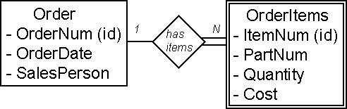

  - ORDER (OrderNum (key), OrderDate, SalesPerson)
ORDERITEMS (OrderNum (key)(fk) , ItemNum (key), PartNum, Quantity, Cost)
    - In the above example, in the ORDERITEMS Relation: OrderNum is the Foreign Key and OrderNum plus ItemNum is the Composite Key.

Chen Notation
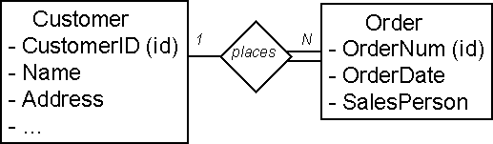

In the ORDER Relation: OrderNum is the Key.

Representing Relationships

  - 1:1 Relationships. The key of one relation is stored in the second relation. Look at example queries to determine which key is queried most often.
  - 1:N Relationships.
Parent - Relation on the "1" side.
Child - Relation on the "Many" side.
  - Represent each Entity as a relation.
Copy the key of the parent into the child relation.

CUSTOMER (CustomerID (key), Name, Address, ...)
ORDER (OrderNum (key), OrderDate, SalesPerson, CustomerID (fk))
  - M:N Relationships. Many to Many relationships can not be directly implemented in relations.
  - Solution: Introduce a third Intersection relation and copy keys from original two relations.

Chen Notation
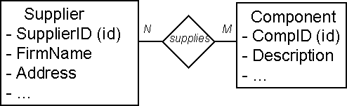

- SUPPLIER (SupplierID (key), FirmName, Address, ...)
- COMPONENT (CompID (key), Description, ...) S
- SUPPLIER_COMPONENT (SupplierID (key), CompID(key))
- Note that this can also be shown in the ER diagram. Also, look for potential added
attributes in the intersection relation.

CONCLUSION:

Thus the ER Database design using E-R model and Normalization was implemented successfully.
Ex.No:10(a) Database Connectivity with Front End Tools

Design and Implementation of Banking System.

Objective:
To design and implement banking system using visual basic 6.0.

Connectivity:
- Open the VB 6.0 in standard exe form and right circle in the tool box select components.
- Select MS ADO data control 6.0 (SP4) OLEDB in component list.
- Right click over ADODC control and select the properties.
- Select MSOLE DB provides for ODBC drivers in provider..

Algorithm:
- Place all the controls in the form as shown.
- To place the ADO controls do the following procedure.
- Go to project→ Component.
- Select the checkbox showing “MICROSOFT ADO DATA CONTROL”and Press
apply→ close.
- Place the ADO control on the form.
- Create a table in SQL plus and insert some values in it.
- Now type the command ‘commit;’ and return back to VB.
- Select the ADO control and click the right mouse select ADODC properties.
- A dialog box will appear, press the build button. Select ‘Microsoft OLEDB provider for oracle” press next button”.
- In the connection tab, give the server name, user name and password.
- Press the” TEST CONNECTION” button. A message box will appear if the steps were followed correctly. Press OK button.
- Select authentication tab. Give the username and password again. Select record source tab. In the table or stored procedure name control box, select the name and give OK.
- Now select the text buttons one by one and in the properties window set the data sources combo box to point to ADODC1.select the corresponding fields of the text box in the data fields combo box
- Write the coding for command buttons and run the form.

Data report :
1. Go to Project->Components->Designers->Data Report,Data Environment and click Apply,then OK.

2. In Project Explorer - > Form1->Right Click-> Add->Data Environment, Data Report.

3. In Data Environment1, Right Click on Connection1->Properties->Provider-> Microsoft OLE DB provider for Oracle -> Next-> Server-orcl, User-itc48,Password-itc
Test Connection->Test Connection Succeeded->OK->OK

4. In Data Environment1,
Right Click on Connection1->Add Command-> Command1

5. In Command1, Right Click->Properties-> Database Object-Table, Object Name – ITB67.BANK - > Apply, then OK

6. Drag Command1 into Detail Section of Data Report1 and Make Alignments

7. In Property Window of DataReport1, change Data Source-Data Environment1
Data Member-Command1.

Database Schema:

Name Null? Type
----------------------------------------- -------- ----------------------------
NAME VARCHAR2(25)
PASS VARCHAR2(26)
ACCNO NUMBER(25)
ACTYPE VARCHAR2(25)
ADDR VARCHAR2(25)
AMT NUMBER(25)

FORM DESIGN:
Form1
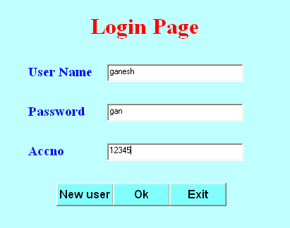
Dim con As New ADODB.Connection
Dim rec As New ADODB.Recordset
Private Sub Command1_Click()
Form3.Show
End Sub

Private Sub Command3_Click()
Unload Me
End Sub

Private Sub Form_Load()
con.Open "Provider=MSDAORA.1;Password=itb;User ID=itb11;Data Source=orcl;Persist Security Info=True"
rec.Open "select * from DET1", con, adOpenDynamic
MsgBox ("successfully connected")
End Sub

Private Sub ok_Click()
Do While Not rec.EOF
If rec.Fields(0) = Text1.Text And rec.Fields(1) = Text2.Text Then
If rec.Fields(2) = Text3.Text Then
Unload Me
Form1.Show
Exit Sub
End If
MsgBox "Accout no is not correct", vbCritical
End If
rec.MoveNext
Loop
MsgBox "user name or password is not correct", vbCritical
Text1.Text = ""
Text2.Text = ""
Text3.Text = ""
Text1.SetFocus
End Sub

Form2
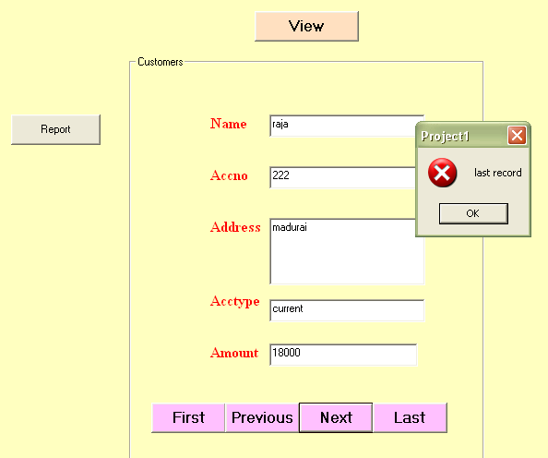

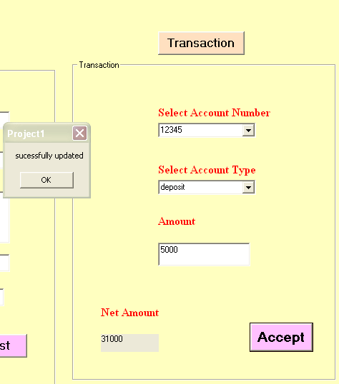

Dim con As New ADODB.Connection
Dim rec As New ADODB.Recordset
Dim con1 As New ADODB.Connection
Dim rec1 As New ADODB.Recordset

Private Sub accept_Click()
If Combo2.Text = "deposit" Then
Label10.Caption = Val(Label10.Caption) + Val(Text6.Text)
con.Execute "update det1 set amt='" & Label10.Caption & "' where accno='" & Combo1.Text & "'"
MsgBox ("sucessfully updated")
Else
If Combo2.Text = "transaction" Then
Form4.Show
Else
If Val(Label10.Caption) >= 501 Then
If Val(Label10.Caption) - Val(Text6.Text) >= 500 Then
Label10.Caption = Val(Label10.Caption) - Val(Text6.Text)
con.Execute "update det1 set amt='" & Label10.Caption & "' where accno='" & Combo1.Text & "'"
MsgBox ("sucessfully debited")
Else
MsgBox "min amt is 500", vbCritical, "below 500"
End If
Else
MsgBox "min amt is 500", vbCritical, "below 500"
End If
End If
End If
accept.Enabled = False
End Sub

Private Sub cmdtrans_Click()
fratrans.Visible = Not fratrans.Visible
End Sub

Private Sub cmdview_Click()
fraview.Visible = Not fraview.Visible
rec.MoveFirst
Text1.Text = rec.Fields(0)
Text2.Text = rec.Fields(2)
Text3.Text = rec.Fields(4)
Text4.Text = rec.Fields(3)
Text5.Text = rec.Fields(5)
End Sub

Private Sub Combo1_Click()
rec.MoveFirst
Do While (rec.EOF = False)
If (StrComp(rec.Fields(2), Combo1.Text) = 0) Then
Label10.Caption = rec.Fields(5)
End If
rec.MoveNext
Loop
accept.Enabled = True
End Sub

Private Sub showrec()
Text1.Text = rec.Fields(0)
Text2.Text = rec.Fields(2)
Text3.Text = rec.Fields(4)
Text4.Text = rec.Fields(3)
Text5.Text = rec.Fields(5)
End Sub

Private Sub Command1_Click()
con1.Open "Provider=MSDAORA.1;Password=itb;User ID=itb11;Data Source=orcl;Persist Security Info=True"
rec1.Open "select * from DET1 where amt>20000", con1, adOpenDynamic
con1.Execute "select * from DET1 where amt>20000"
MsgBox ("successfully generated")
DataReport1.Show
End Sub

Private Sub first_Click()
rec.MoveFirst
showrec
End Sub

Private Sub Form_Load()
con.Open "Provider=MSDAORA.1;Password=itb;User ID=itb11;Data Source=orcl;Persist Security Info=True"
rec.Open "select * from DET1", con, adOpenDynamic
MsgBox ("successfully connectted")
rec.MoveFirst
Do While Not rec.EOF
Combo1.AddItem rec.Fields(2)
rec.MoveNext
Loop
Combo2.AddItem "deposit"
Combo2.AddItem "withdraw"
Combo2.AddItem "transaction"
fraview.Visible = False
fratrans.Visible = False
End Sub

Private Sub last_Click()
rec.MoveLast
showrec
End Sub

Private Sub next_Click()
rec.MoveNext
If rec.EOF = True Then
MsgBox "last record", vbCritical
rec.MoveLast
End If
showrec
End Sub

Private Sub previous_Click()
rec.MovePrevious
If rec.BOF = True Then
MsgBox "first record", vbCritical
rec.MoveFirst
End If
showrec
End Sub

Private Sub clear()
Text1.Text = ""
Text2.Text = ""
Text3.Text = ""
Text4.Text = ""
Text5.Text = ""
End Sub

Form3
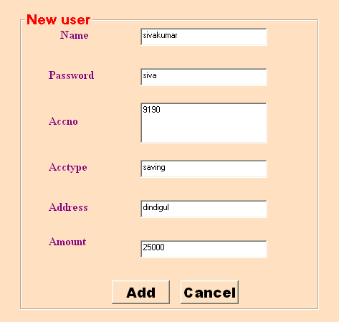
Dim con As New ADODB.Connection
Dim rec As New ADODB.Recordset
Private Sub Add_Click()
con.Execute "insert into det1 values('" & Text1.Text & "','" & Text2.Text & "','" & Val(Text3.Text) & "','" & Text4.Text & "','" & Text5.Text & "','" & Val(Text6.Text) & "')"
MsgBox "record updated", vbInformation, "ok"
Unload Me
End Sub

Private Sub Cancel_Click()
Text1.Text = ""
Text2.Text = ""
Text3.Text = ""
Text4.Text = ""
Text5.Text = ""
Text6.Text = ""
rec.AddNew
End Sub

Private Sub Form_Activate()
Text1.SetFocus
End Sub
Private Sub Form_Load()
con.Open "Provider=MSDAORA.1;Password=itb;User ID=itb11;Data Source=orcl;Persist Security Info=True"
rec.Open "select * from DET1", con, adOpenDynamic
MsgBox ("successfully connectted")
End Sub
DataReport
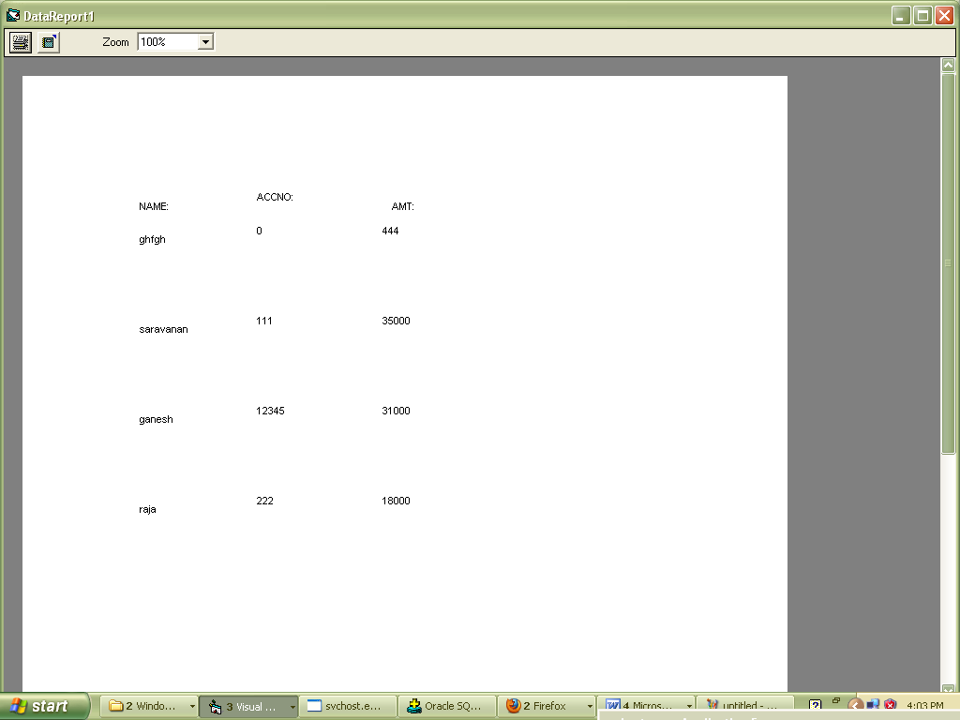
Conclusion:
Thus the Banking system was successfully designed using VB6.0 and ORACLE.

Ex.No:10(b) Design and Implementation of Payroll Processing System.
Date:

OBJECTIVE:
To design and implement payroll processing system using visual basic 6.0.

Connectivity:
i.Open the VB 6.0 in standard exe form and right circle in the tool box select components.
ii.Select MS ADO data control 6.0 (SP4) OLEDB in component list.
iii. Right click over ADODC control and select the properties.
iv. Select MSOLE DB provides for ODBC drivers in provider.

Algorithm:

- Place all the controls in the form as shown.
- To place the ADO controls do the following.
- Go to Project -->components.
- Select the checkbox showing Microsoft ADO data control.
- Press apply close.
- Create table in SQL plus & insert some values in it.
- Now type the command “commit” & return to VB.
- Select Ado control & click right mouse button select ADOBC button.
- A dialog box will appear press the build button, select ms OLE DB provider the
oracle press next button.
- In connection tab give the server name, username & password.
- Press test connection button a msg box will appear of step were followed
connectivity press “OK”.
- Select authorization tab,give username & password again select , select record
source tab in the command type.
- Now select the next button one by one and in properties window set the data source.
Database Schema:

Column Name Datatype
ENAME VARCHAR2(20)
EID NUMBER(5)
DESG VARCHAR2(20)
BASICPAY NUMBER(10)
HRA NUMBER(10)
DA NUMBER(10)
TA NUMBER(10)
GP NUMBER(10)

Problem Solution:

SQL> create table pay(ename varchar2(20),eid number(5),desg varchar2(20),basicpay number(10),hra number(10),da number(10),ta number(10),gp number(10));
Table created.
SQL> insert into pay values('&ename',&eid,'&desg',&Basicpay,&hra,&da,&ta,&gp);
1 row created.
SQL> select * from pay;
ENAME EID DESG BASICPAY HRA DA TA GP
------------- ---------- -------------------- ---------- -------------------- ---------- ----------
aaa 111 mgr 20000 5000 30000 40000 35000

bbb 222 clerk 10000 1000 2000 25000 20000

ccc 333 suprvr 12000 2000 4000 35000 30000

SQL> commit;
Commit complete.
FORM 1:

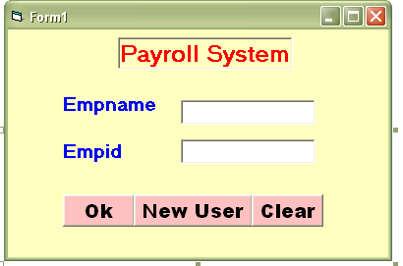
FORM 1:
Dim con As New ADODB.Connection
Dim rec As New ADODB.Recordset
Private Sub clear_Click()
Text1.Text = ""
Text2.Text = ""
Text1.SetFocus
End Sub
Private Sub Form_Load()
con.Open "Provider=MSDAORA.1;Password=itc;User ID=itc48;Data Source=orcl;Persist Security Info=True"
rec.Open "select * from pay", con, adOpenDynamic
MsgBox ("successfully connected")
End Sub
Private Sub newuser_Click()
Form1.Hide
Form3.Show
End Sub
Private Sub ok_Click()
Do While Not rec.EOF
If rec.Fields(0) = Text1.Text And rec.Fields(1) = Text2.Text Then
Form1.Hide
Form2.Show
Exit Sub
End If
rec.MoveNext
Loop
MsgBox "user name or password is not correct", vbCritical
Text1.Text = ""
Text2.Text = ""
Text1.SetFocus
End Sub
Form 2:
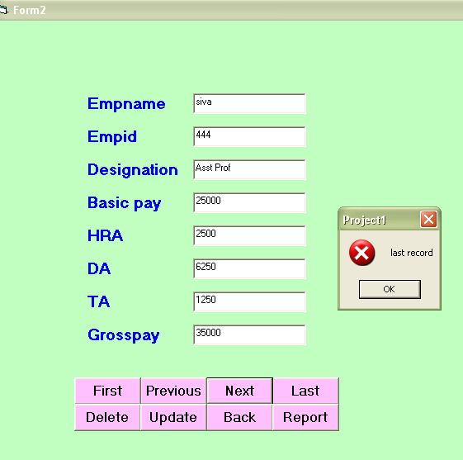
Dim con As New ADODB.Connection
Dim rec As New ADODB.Recordset
Private Sub Back_Click()
Form2.Hide
Form1.Show
End Sub
Private Sub delete_Click()
con.Execute "delete from pay where eid='" & Text2.Text & "'"
MsgBox ("record deleted")
End Sub
Private Sub Form_Load()
con.Open "Provider=MSDAORA.1;Password=itc;User ID=itc48;Data Source=orcl;Persist Security Info=True"
rec.Open "select * from pay", con, adOpenDynamic
MsgBox ("successfully connected")
rec.MoveFirst
Text1.Text = rec.Fields(0)
Text2.Text = rec.Fields(1)
Text3.Text = rec.Fields(2)
Text4.Text = rec.Fields(3)
Text5.Text = rec.Fields(4)
Text6.Text = rec.Fields(5)
Text7.Text = rec.Fields(6)
Text8.Text = rec.Fields(7)
End Sub
Private Sub first_Click()
rec.MoveFirst
showrec
End Sub
Private Sub last_Click()
rec.MoveLast
showrec
End Sub
Private Sub showrec()
Text1.Text = rec.Fields(0)
Text2.Text = rec.Fields(1)
Text3.Text = rec.Fields(2)
Text4.Text = rec.Fields(3)
Text5.Text = rec.Fields(4)
Text6.Text = rec.Fields(5)
Text7.Text = rec.Fields(6)
Text8.Text = rec.Fields(7)
End Sub
Private Sub next_Click()
rec.MoveNext
If rec.EOF = True Then
MsgBox "last record", vbCritical
rec.MoveLast
End If
showrec
End Sub
Private Sub previous_Click()
rec.MovePrevious
If rec.BOF = True Then
MsgBox "first record", vbCritical
rec.MoveFirst
End If
showrec
End Sub
Private Sub Report_Click()
DataReport1.Show
End Sub
Private Sub Update_Click()
con.Execute "update pay set ename='" & Text1.Text & "',desg='" & Text3.Text & "',basicpay='" & Text4.Text & "' where eid='" & Text2.Text & "'"
MsgBox ("record updated")
End Sub
Form 3:
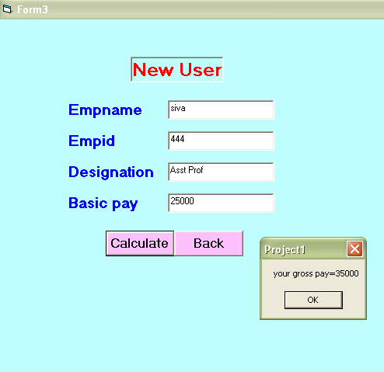

Dim con As New ADODB.Connection
Dim rec As New ADODB.Recordset
Dim DA As Integer
Dim HRA As Integer
Dim TA As Integer
Dim GP As Double
Private Sub Back_Click()
Form3.Hide
Form1.Show
End Sub
Private Sub calculate_Click()
HRA = 0.1 * Val(Text4.Text)
DA = 0.25 * Val(Text4.Text)
TA = 0.05 * Val(Text4.Text)
GP = HRA + DA + TA + Val(Text4.Text)
con.Execute "insert into pay values('" & Text1.Text & "','" & Text2.Text & "','" & Text3.Text & "','" & Text4.Text & "','" & HRA & "','" & DA & "','" & TA & "','" & GP & "')"
MsgBox ("your gross pay=" & Val(GP))
End Sub
Private Sub Form_Load()
con.Open "Provider=MSDAORA.1;Password=itc;User ID=itc48;Data Source=orcl;Persist Security Info=True"
rec.Open "select * from pay", con, adOpenDynamic
MsgBox ("successfully connected")
End Sub
DATA REPORT :
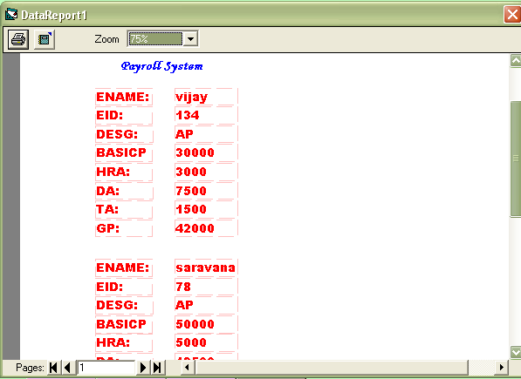

Conclusion:

Thus the Payroll system was successfully designed using VB6.0 and ORACLE.

Ex.No:10 Case Study using real life database applications
Design and Implementation of E-Ticketing Processing System.
Objective:
To design and implement E-Ticketing Processing System using visual basic 6.0.

Connectivity:
i.Open the VB 6.0 in standard exe form and right circle in the tool box select components.
ii.Select MS ADO data control 6.0 (SP4) OLEDB in component list.
iii. Right click over ADODC control and select the properties.
iv. Select MSOLE DB provides for ODBC drivers in provider.

Algorithm:
- Place all the controls in the form as shown.
- To place the ADO controls do the following.
- Go to Project -->components.
- Select the checkbox showing Microsoft ADO data control.
- Press apply close.
- Create table in SQL plus & insert some values in it.
- Now type the command “commit” & return to VB.
- Select Ado control & click right mouse button select ADOBC button.
- A dialog box will appear press the build button, select ms OLE DB provider the oracle press next button.
- In connection tab give the server name, username & password.
- Press test connection button a msg box will appear of step were followed connectivity press “OK”.
- Select authorization tab, give username & password again select , select record source tab in the command type.
- Now select the next button one by one and in properties window set the data source.

Database Schema:
TABLE : et1
Name Null? Type
----------------------------------------------------- -------- ----------------------------------
ID VARCHAR2(10)
PWD VARCHAR2(10)

TABLE :ett1
Name Null? Type
----------------------------------------------------- -------- ---------------
SOURCE VARCHAR2(20)
DEST VARCHAR2(20)
TRNAME VARCHAR2(20)
TRNO VARCHAR2(20)
COST NUMBER(20)
TICKETS VARCHAR2(20)
TABLE :ett2
Name Null? Type
----------------------------------------------------- -------- --------------
NAME VARCHAR2(20)
AGE VARCHAR2(20)
GENDER VARCHAR2(20)
SRCE VARCHAR2(20)
DEST VARCHAR2(20)
TRNAME VARCHAR2(20)
TRNO VARCHAR2(20)
TICKETS VARCHAR2(20)
TOTAL VARCHAR2(20)

CODINGS
CODINGS FOR LOGIN

Dim con As New ADODB.Connection
Dim rs As New ADODB.Recordset

Private Sub Login_Click()
rs.MoveFirst
Do While Not rs.EOF
If rs(0) = Text1.Text And rs(1) = Text2.Text Then
Form2.Show
Form1.Hide
End If
rs.MoveNext
Loop
End Sub

Private Sub Exit_Click()
Unload Me
End Sub

Private Sub Form_Load()
con.Open"Provider=MSDAORA.1;Password=itc;UserID=itc48;Data Source=orcl;Persist Security Info=True"
rs.Open "select * from ett1", con, adOpenDynamic
End Sub

CODINGS FOR AVAILABILITY

Dim con As New ADODB.Connection
Dim rs As New ADODB.Recordset

Private Sub get_Click()
rs.MoveFirst
Do While Not rs.EOF
If Combo1.Text = rs(0) And Combo2.Text = rs(1) Then
Text1.Text = rs(2)
Text2.Text = rs(3)
Text3.Text = rs(4)
Text4.Text = rs(5)
End If
rs.MoveNext
Loop
End Sub

Private Sub Availability_Click()
rs.MoveFirst
Do While Not rs.EOF
If Combo1.Text = rs(0) And Combo2.Text = rs(1) Then
If rs(5) >= Val(Text4.Text) Then
MsgBox "Tickets are available"
Else
MsgBox "Sorry!!!!!Tickets are not available"
End If
End If
rs.MoveNext
Loop
End Sub

Private Sub Reserve_Click()
Form3.Show
Form2.Hide
End Sub

Private Sub Cancel_Click()
Form4.Show
Form2.Hide
End Sub

Private Sub exit_Click()
Unload Me
End Sub

Private Sub home_Click()
Form1.Show
End Sub

Private Sub Form_Load()
con.Open"Provider=MSDAORA.1;Password=itc;UserID=itc48;Data Source=orcl;Persist Security Info=True"
rs.Open "select * from ett1", con, adOpenDynamic
rs.MoveFirst
Do While Not rs.EOF
Combo1.AddItem (rs(0))
Combo2.AddItem (rs(1))
rs.MoveNext
Loop
End Sub

CODINGS FOR RESERVATION

Dim con As New ADODB.Connection
Dim rs As New ADODB.Recordset
Dim con1 As New ADODB.Connection
Dim rs1 As New ADODB.Recordset
Dim a As Integer
Private Sub home_Click()
Form1.Show
End Sub
Private Sub Reserve_Click()
con.Execute "select * from ett2"
con1.Execute "select * from ett1"
rs1.MoveFirst
Do While Not rs1.EOF
If Text6.Text = rs1(3) Then
con1.Execute "update ett1 set tickets='" & rs1(5) - Val(Text8.Text) & "' where trno='" & Text6.Text & "'"
con.Execute "insert into ett2 values('" & Text1.Text & "','" & Text2.Text & "' , '" & Combo1.Text & "', '" & Text3.Text & "','" & Text4.Text & "','" & Text5.Text & "','" & Text6.Text & "','" & Text8.Text & "','" & Text9.Text & "')"
MsgBox "Ticket is reserved"
Text1.Text = ""
Text2.Text = ""
Combo1.Text = ""
Text8.Text = ""
Exit Sub
End If
rs1.MoveNext
Loop
End Sub

Private Sub exit_Click()
Unload Me
End Sub

Private Sub Form_Load()
con.Open"Provider=MSDAORA.1;Password=itc;UserID=itc48;Data Source=orcl;Persist Security Info=True"
rs.Open "select * from ett1", con, adOpenDynamic
con1.Open"Provider=MSDAORA.1;Password=itc;UserID=itc48;Data Source=orcl;Persist Security Info=True"
rs1.Open "select * from ett2", con, adOpenDynamic
Text3.Text = Form2.Combo1.Text
Text4.Text = Form2.Combo2.Text
Text5.Text = Form2.Text1.Text
Text6.Text = Form2.Text2.Text
Text7.Text = Form2.Text3.Text
Combo1.AddItem "Male"
Combo1.AddItem "Female"
End Sub

Private Sub Text8_LostFocus()
Text9.Text = Val(Text7.Text) * Val(Text8.Text)
End Sub

CODINGS FOR CANCELLATION

Dim con1 As New ADODB.Connection
Dim rs1 As New ADODB.Recordset
Dim con2 As New ADODB.Connection
Dim rs2 As New ADODB.Recordset

Private Sub Combo2_LostFocus()
rs1.MoveFirst
Do While Not rs1.EOF
If Combo1.Text = rs1(0) And Combo2.Text = rs1(1) Then
Text3.Text = rs1(2)
Text4.Text = rs1(3)
End If
rs1.MoveNext
Loop
End Sub

Private Sub Cancel_Click()
con2.Execute "select * from ett2"
con1.Execute "select * from ett1"
rs2.MoveFirst
Do While Not rs2.EOF
If rs2(0) = Text1.Text And rs2(1) = Text2.Text Then
con2.Execute "delete ett2 where name='" & Text1.Text & "' and age='" & Text2.Text & "'"
rs1.MoveFirst
Do While Not rs1.EOF
If Text4.Text = rs1(3) Then
con1.Execute "update ett1 set tickets='" & rs1(5) + Val(Text5.Text) & "' where trno='" & Text4.Text & "'"
MsgBox "Ticket is cancelled"
'Text1.Text = ""
'Text2.Text = ""
'Combo1.Text = ""
'Text8.Text = ""
End If
rs1.MoveNext
Loop
Exit Sub
End If
rs2.MoveNext
Loop
End Sub

Private Sub home_Click()
Form1.Show
End Sub

Private Sub Form_Load()
con1.Open"Provider=MSDAORA.1;Password=itc;UserID=itc48;Data Source=orcl;Persist Security Info=True"
rs1.Open "select * from ett1", con, adOpenDynamic
con2.Open"Provider=MSDAORA.1;Password=itc;UserID=itc48;Data Source=orcl;Persist Security Info=True"
rs2.Open "select * from ett2", con, adOpenDynamic
rs1.MoveFirst
Do While Not rs1.EOF
Combo1.AddItem (rs1(0))
Combo2.AddItem (rs1(1))
rs1.MoveNext
Loop
End Sub

LOGIN FORM

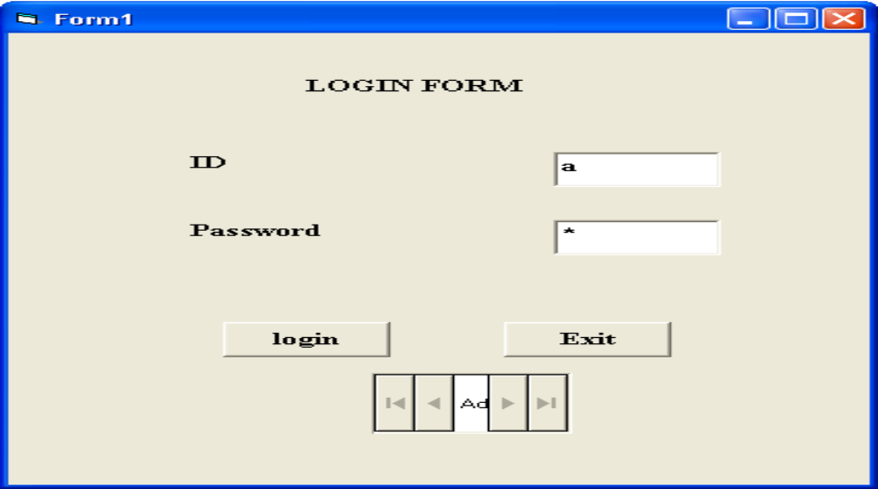

AVAILABILITY FORM

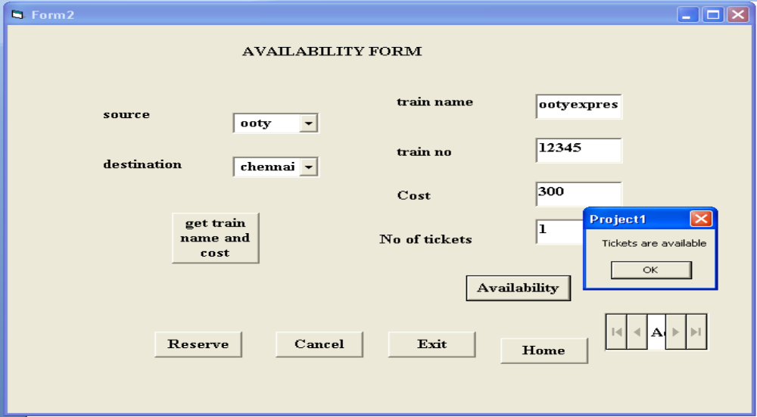

RESEVATION FORM

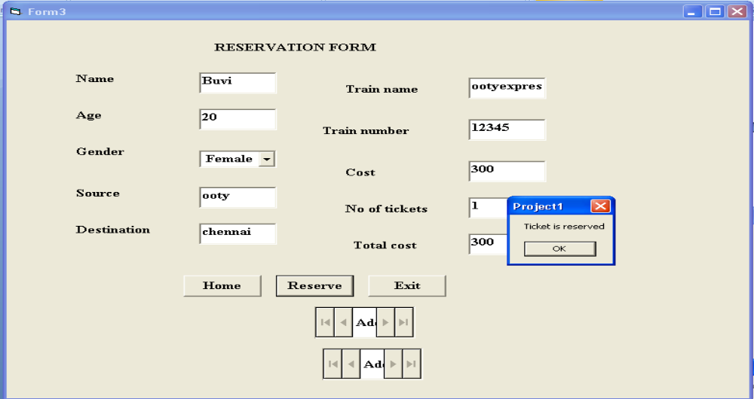

CANCELLATION FORM

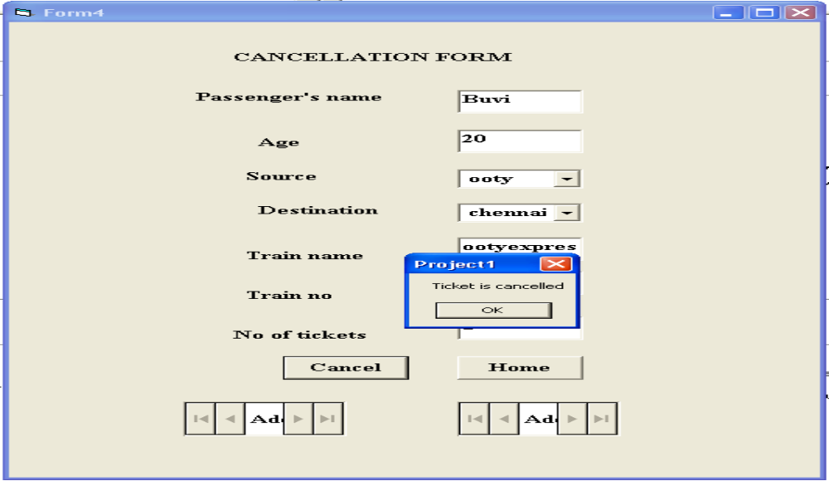

CONCLUSION
The project for “E-TICKETING” was created and the ticket was reserved successfully. If we want to cancel the ticket means that also available in this project. Before reserve ticket we check the availability of tickets using some source and destination place.

